**Practical 0**

**Introduction to Android, Introduction to Android Studio IDE, Application Fundamentals**

**Aim: Creating a simple project with “Hello World” program.**

**Steps to create Project:**

1. 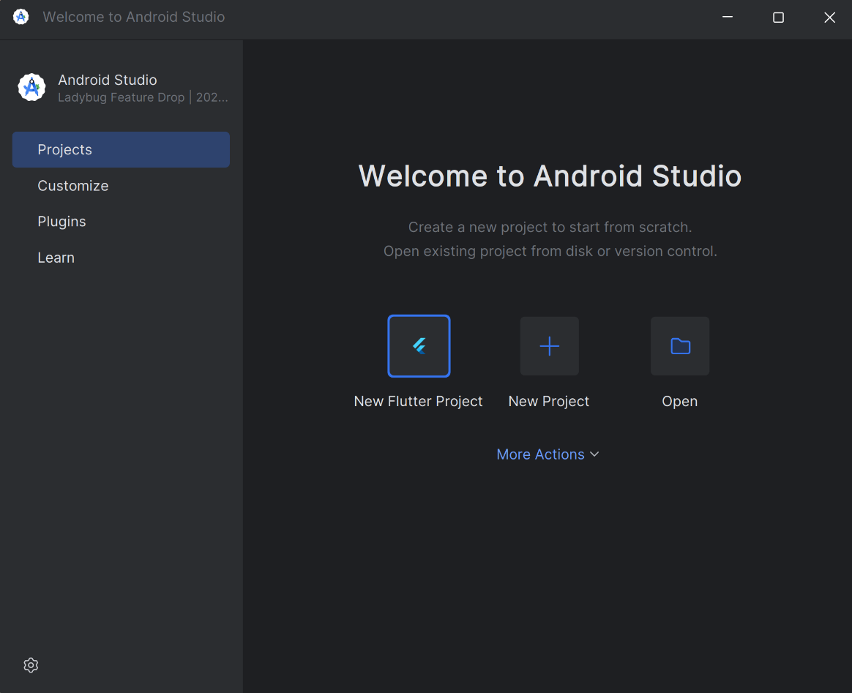Open Android Studio 🡪 Click on ‘New Project’.
2. Select ‘Empty View Activity’.

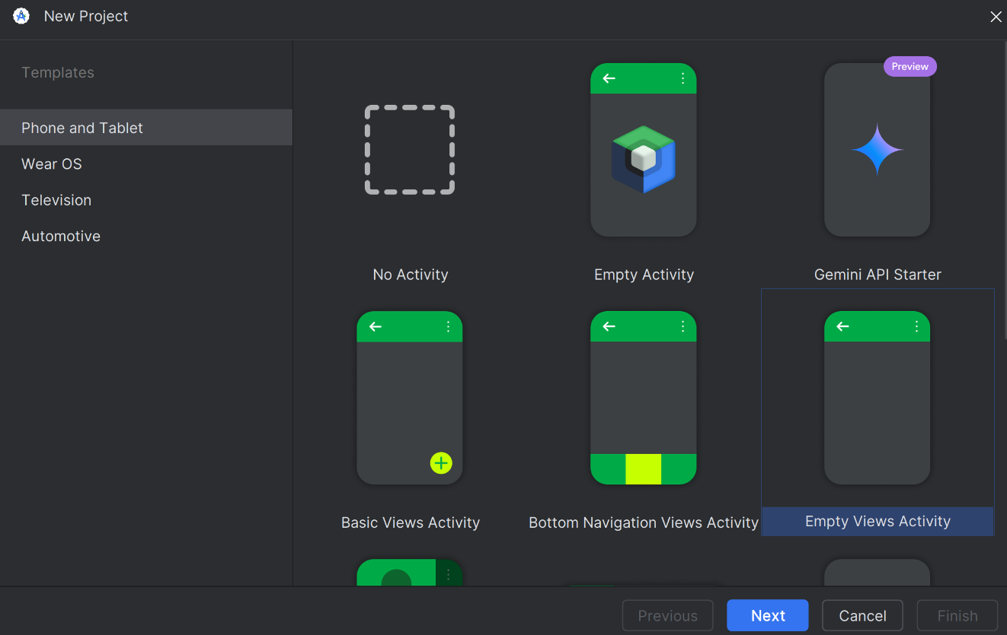

1. Give Project Name as ‘**P0**’ 🡪Select ‘Java’ in language. Click ‘Finish’.

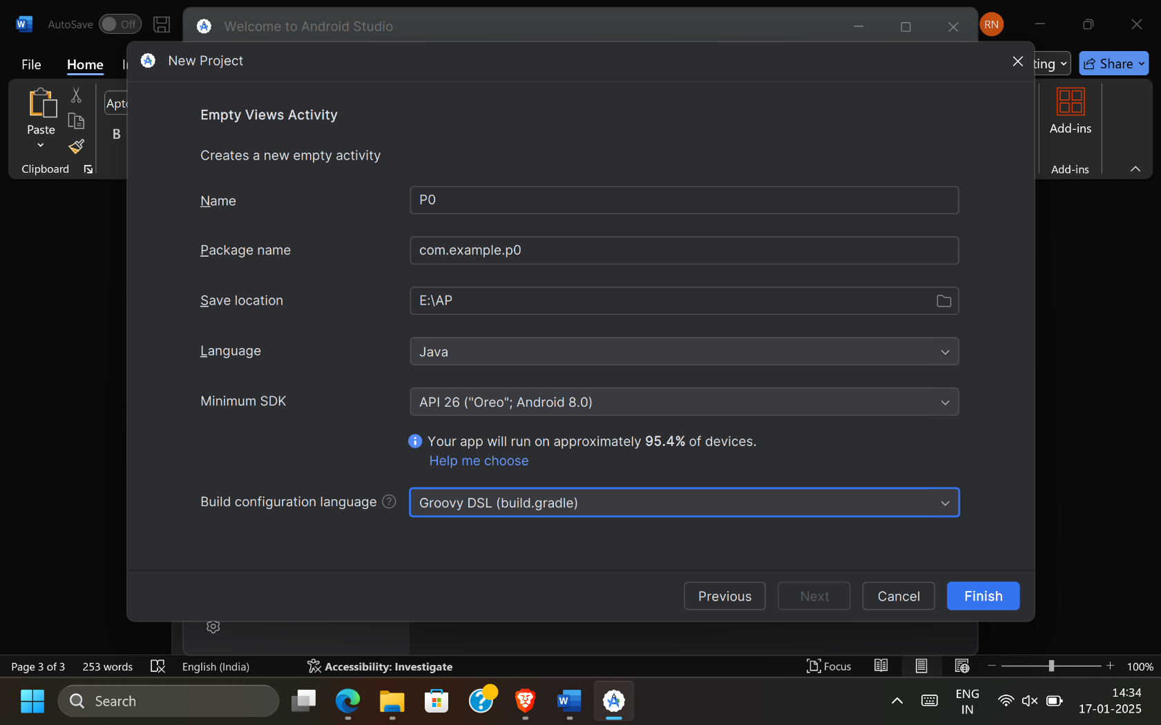

1. ‘Project (P0)’ is successfully created.

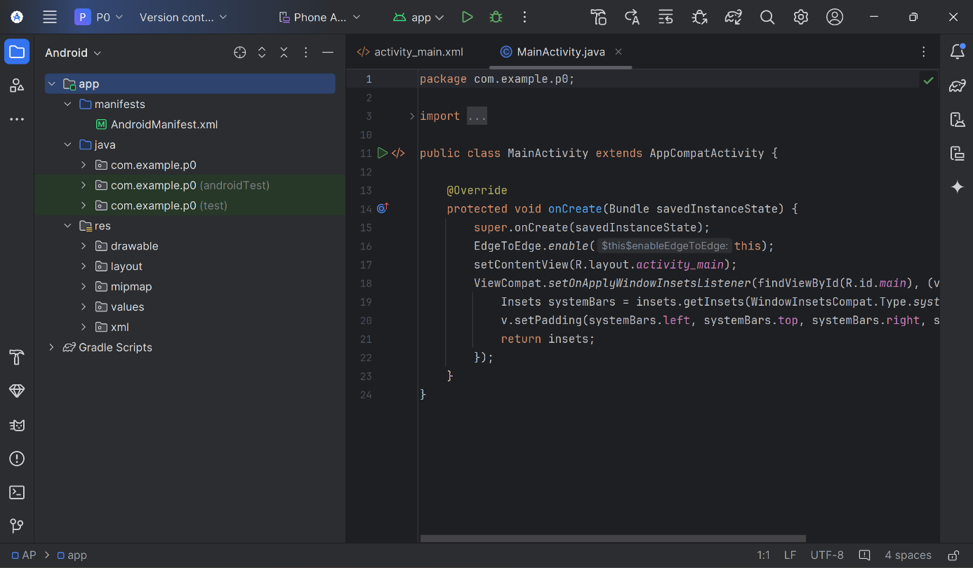

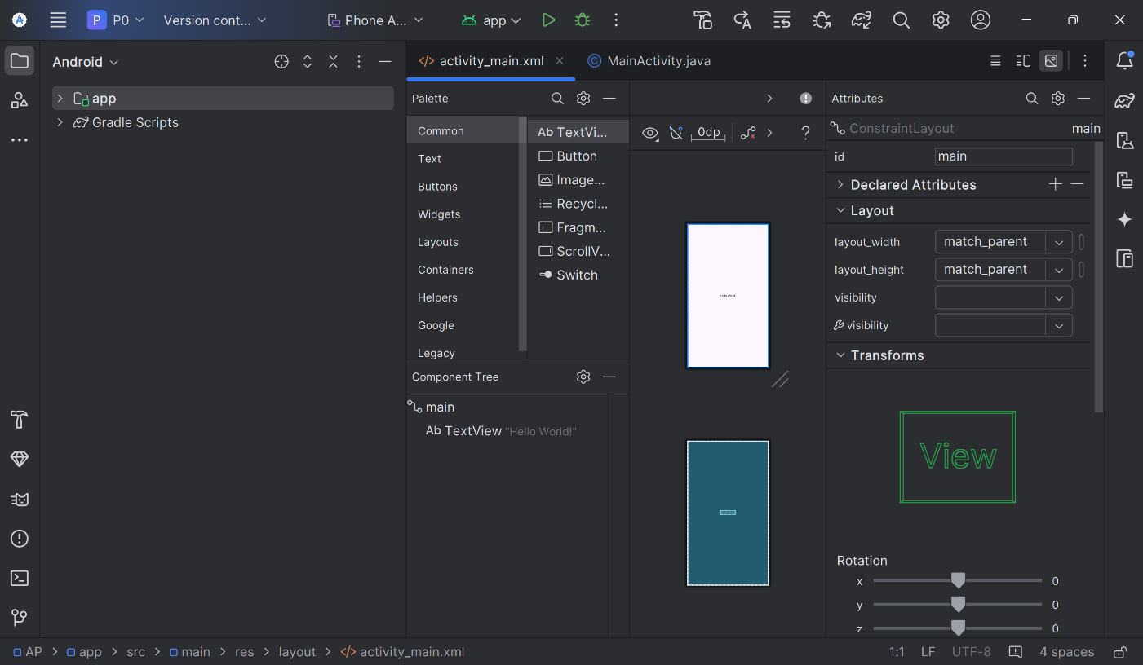

**Code: MainActivity.java**

package com.example.prac_0;  
import android.os.Bundle;  
  
import androidx.activity.EdgeToEdge;  
import androidx.appcompat.app.AppCompatActivity;  
import androidx.core.graphics.Insets;  
import androidx.core.view.ViewCompat;  
import androidx.core.view.WindowInsetsCompat;  
  
public class MainActivity extends AppCompatActivity {  
 @Override  
 protected void onCreate(Bundle savedInstanceState) {  
 super.onCreate(savedInstanceState);  
 EdgeToEdge.*enable*(this);  
 setContentView(R.layout.*activity_main*);  
 ViewCompat.*setOnApplyWindowInsetsListener*(findViewById(R.id.*main*), (v, insets) -> {  
 Insets systemBars = insets.getInsets(WindowInsetsCompat.Type.*systemBars*());  
 v.setPadding(systemBars.left, systemBars.top, systemBars.right, systemBars.bottom);  
 return insets; }); }}

**activity_main.xml**

<?xml version="1.0" encoding="utf-8"?>  
<androidx.constraintlayout.widget.ConstraintLayout xmlns:android="http://schemas.android.com/apk/res/android"  
 xmlns:app="http://schemas.android.com/apk/res-auto"  
 xmlns:tools="http://schemas.android.com/tools"  
 android:id="@+id/main"  
 android:layout_width="match_parent"  
 android:layout_height="match_parent"  
 tools:context=".MainActivity">  
 <TextView  
 android:layout_width="wrap_content"  
 android:layout_height="wrap_content"  
 android:text="Hello World!"  
 app:layout_constraintBottom_toBottomOf="parent"  
 app:layout_constraintEnd_toEndOf="parent"  
 app:layout_constraintStart_toStartOf="parent"  
 app:layout_constraintTop_toTopOf="parent" />  
</androidx.constraintlayout.widget.ConstraintLayout>

**Steps to run the project:**

1. Open ‘Device Manager’

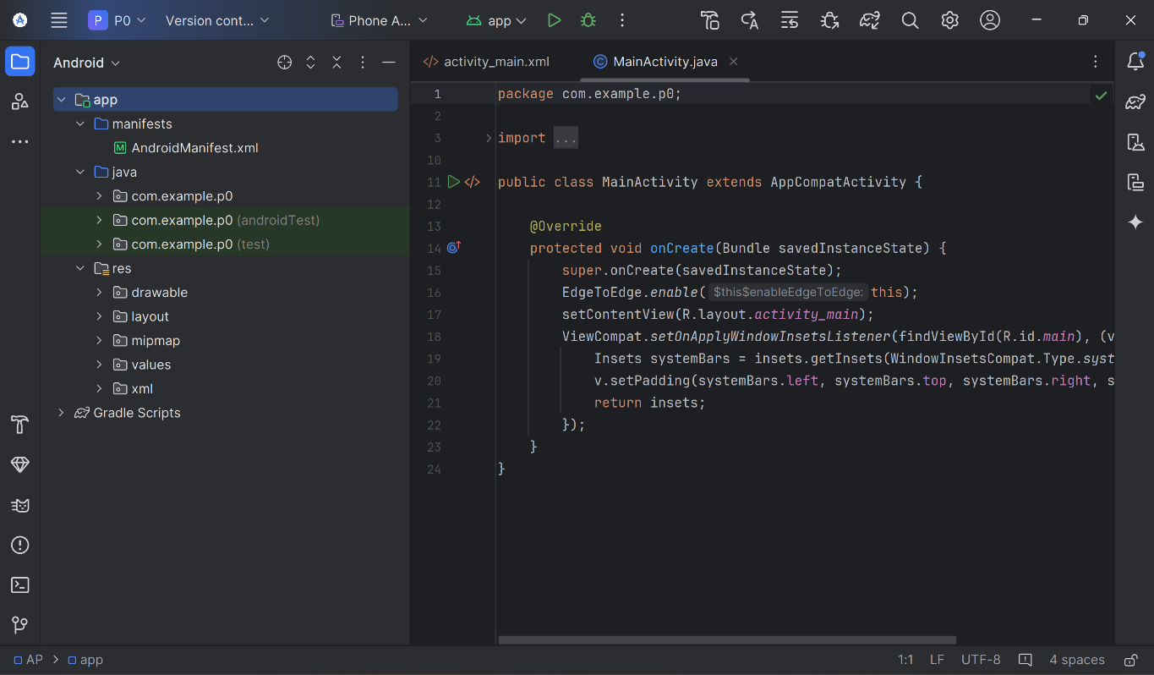

1. Click on ‘Play’ button (which will turn on the device).

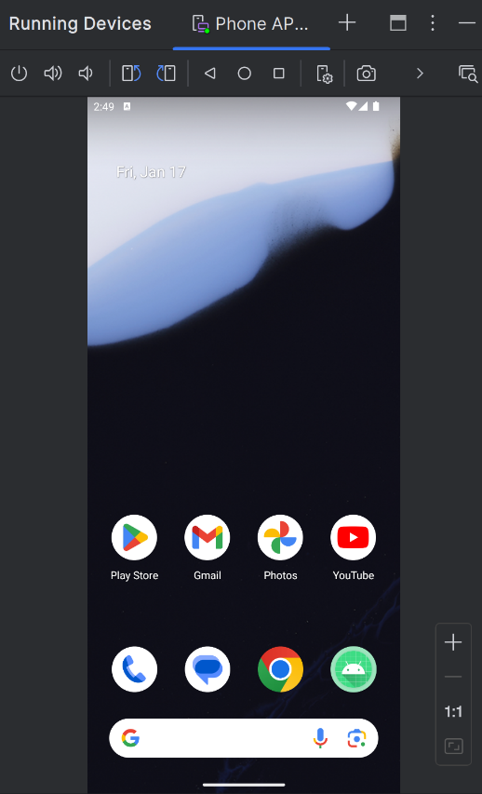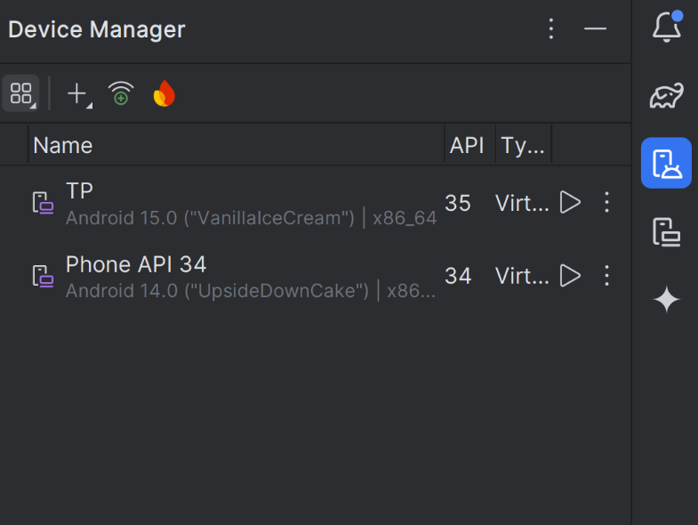

**Practical No. 1**

**Practical 1**

**Aim:** Android Programming Resources : (Colour, Theme, String, Dimension, Image).

**activity_main.xml**

<?xml version="1.0" encoding="utf-8"?>  
<LinearLayout xmlns:android="http://schemas.android.com/apk/res/android"  
 xmlns:app="http://schemas.android.com/apk/res-auto"  
 xmlns:tools="http://schemas.android.com/tools"  
 android:layout_width="match_parent"  
 android:layout_height="match_parent"  
 android:orientation="vertical"  
 tools:context=".MainActivity">  
 <TextView  
 android:id="@+id/textView"  
 android:layout_width="@dimen/d1"  
 android:layout_height="wrap_content"  
 android:background="@color/d4"  
 android:text="My application"  
 android:textColor="@color/white"  
 app:layout_constraintBottom_toBottomOf="parent"  
 app:layout_constraintEnd_toEndOf="parent"  
 app:layout_constraintStart_toStartOf="parent"  
 app:layout_constraintTop_toTopOf="parent"  
 app:layout_constraintVertical_bias="0.022" />  
 <TextView  
 android:id="@+id/textView2"  
 android:layout_width="@dimen/d2"  
 android:layout_height="wrap_content"  
 android:background="@color/d1"  
 android:rotationX="4"  
 android:text="@string/t1"  
 android:textColor="#212121"  
 app:layout_constraintBottom_toBottomOf="parent"  
 app:layout_constraintEnd_toEndOf="parent"  
 app:layout_constraintStart_toStartOf="parent"  
 app:layout_constraintTop_toTopOf="parent" />  
 <ImageView  
 android:id="@+id/imageView"  
 android:layout_width="135dp"  
 android:layout_height="180dp"  
 app:srcCompat="@drawable/circle" />  
 <ImageView  
 android:id="@+id/imageView3"  
 android:layout_width="136dp"  
 android:layout_height="181dp"  
 app:srcCompat="@drawable/random" />  
</LinearLayout>

**strings.xml**

<resources>  
 <string name="app_name">pract1</string>  
 <string name="t1">This Application will help You.</string>  
</resources>

**themes.xml**

<resources xmlns:tools="http://schemas.android.com/tools">  
 <!-- Base application theme. -->  
 <style name="Base.Theme.Pract1" parent="Theme.Material3.DayNight.NoActionBar">  
 <!-- Customize your light theme here. -->  
 <!-- <item name="colorPrimary">@color/my_light_primary</item> -->  
 </style>  
 <style name="Theme.Pract1" parent="Base.Theme.Pract1" >  
 <item name="android:textColor">#ff0810</item>  
 <item name="android:background">#aa9911</item>  
 </style>  
</resources>

**colors.xml**

<?xml version="1.0" encoding="utf-8"?>  
<resources>  
 <color name="black">#FF000000</color>  
 <color name="white">#FFFFFFFF</color>  
 <color name="d1">#dd6776</color>  
 <color name="d2">#ddaacc</color>  
 <color name="d3">#ff5566</color>  
 <color name="d4">#aa11aa</color>  
</resources>

**dimens.xml**

<?xml version="1.0" encoding="utf-8"?>  
<resources>  
 <dimen name="d1">350px</dimen>  
 <dimen name="d2">350px</dimen>  
</resources>

**Output:**

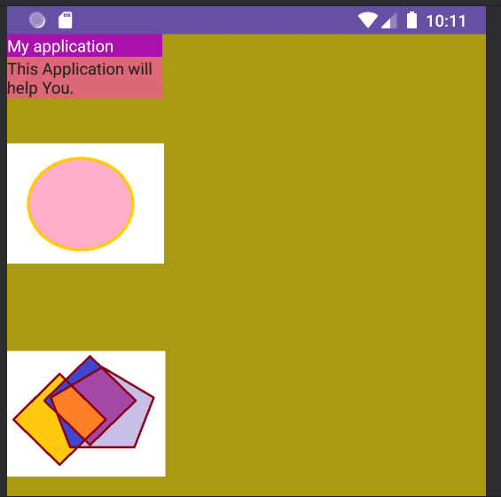

**Practical No. 2**

**Practical 2A**

**Aim:** Life Cycle of Androids Activity

**MainActivity.java**

package com.example.prac2b;

import android.os.Bundle;

import androidx.appcompat.app.AppCompatActivity;

import android.util.Log;

public class MainActivity extends AppCompatActivity {

String tag = "Lifecycle";

@Override

protected void onCreate(Bundle savedInstanceState) {

super.onCreate(savedInstanceState);

setContentView(R.layout.activity_main);

Log.d(tag, "In the onCreate() event");

}

@Override

protected void onStart() {

super.onStart();

Log.d(tag, "In the onStart() event");

}

@Override

protected void onRestart() {

super.onRestart();

Log.d(tag, "In the onRestart() event");

}

@Override

protected void onResume() {

super.onResume();

Log.d(tag, "In the onResume() event");

}

@Override

protected void onPause() {

super.onPause();

Log.d(tag, "In the onPause() event");

}

@Override

protected void onStop() {

super.onStop();

Log.d(tag, "In the onStop() event");

}

@Override

protected void onDestroy() {

super.onDestroy();

Log.d(tag, "In the onDestroy() event");

    }

}

**Output:**

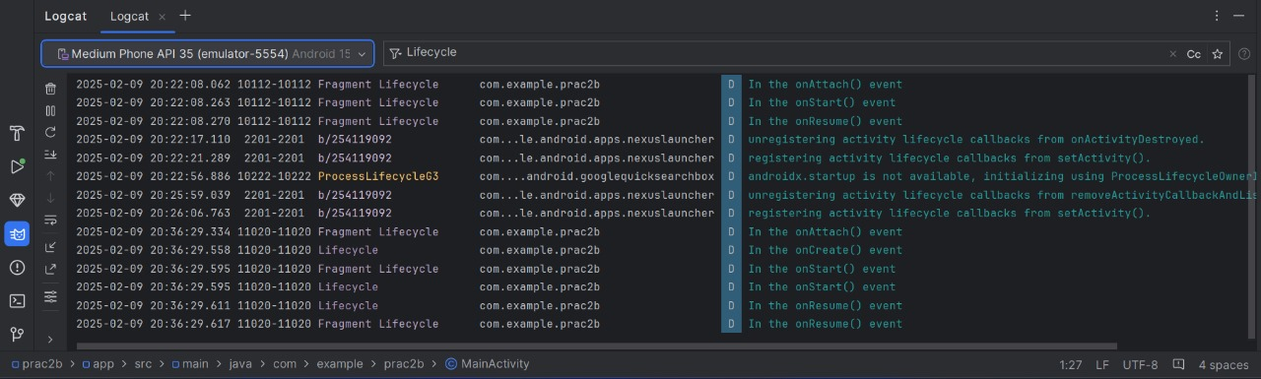

**Practical 2B**

**Aim:** Creating a Fragment

**activity_main.xml**

<?xml version="1.0" encoding="utf-8"?>

<androidx.constraintlayout.widget.ConstraintLayout

xmlns:android="http://schemas.android.com/apk/res/android"

xmlns:app="http://schemas.android.com/apk/res-auto"

xmlns:tools="http://schemas.android.com/tools"

android:layout_width="match_parent"

android:layout_height="match_parent"

tools:context=".MainActivity">

<!-- Take a fragment in our activity -->

<fragment

android:id="@+id/test_fragment"

android:layout_width="match_parent"

android:layout_height="match_parent"

class="com.example.prac2b.BlankFragment"

tools:layout="@layout/fragment_blank" />

</androidx.constraintlayout.widget.ConstraintLayout>

**MainActivity.java**

package com.example.prac2b;

import android.os.Bundle;

import androidx.appcompat.app.AppCompatActivity;

public class MainActivity extends AppCompatActivity {

@Override

protected void onCreate(Bundle savedInstanceState) {

super.onCreate(savedInstanceState);

setContentView(R.layout.activity_main);

    }

}

**fragment_blank.xml**

<?xml version="1.0" encoding="utf-8"?>

<FrameLayout xmlns:android="http://schemas.android.com/apk/res/android"

xmlns:tools="http://schemas.android.com/tools"

android:layout_width="match_parent"

android:layout_height="match_parent"

tools:context=".BlankFragment">

<TextView

android:layout_width="match_parent"

android:layout_height="match_parent"

android:textSize="48dp"

android:text="Check Logcat" />

</FrameLayout>

**BlankFragment.java**

package com.example.prac2b;

import android.content.Context;

import android.os.Bundle;

import androidx.annotation.NonNull;

import androidx.fragment.app.Fragment;

import android.view.LayoutInflater;

import android.view.View;

import android.view.ViewGroup;

import android.util.Log;

public class BlankFragment extends Fragment {

String tag = "Fragment Lifecycle";

@Override

public void onAttach(@NonNull Context context) {

super.onAttach(context);

Log.d(tag, "In the onAttach() event");

}@Override

public void onStart() {

super.onStart();

Log.d(tag, "In the onStart() event");

} @Override

public void onResume() {

super.onResume();

Log.d(tag, "In the onResume() event");

}@Override

public void onPause() {

super.onPause();

Log.d(tag, "In the onPause() event");

}@Override

public void onStop() {

super.onStop();

Log.d(tag, "In the onStop() event");

}

@Override

public void onDestroy() {

super.onDestroy();

Log.d(tag,"In the onDestroy() event");

}

private static final String ARG_PARAM1 = "param1";

private static final String ARG_PARAM2 = "param2";

private String mParam1;

private String mParam2;

public BlankFragment() {

// Required empty public constructor

}

public static BlankFragment newInstance(String param1, String param2) {

BlankFragment fragment = new BlankFragment();

Bundle args = new Bundle();

args.putString(ARG_PARAM1, param1);

args.putString(ARG_PARAM2, param2);

fragment.setArguments(args);

return fragment;

}

@Override

public void onCreate(Bundle savedInstanceState) {

super.onCreate(savedInstanceState);

if (getArguments() != null) {

mParam1 = getArguments().getString(ARG_PARAM1);

mParam2 = getArguments().getString(ARG_PARAM2);

}}

@Override

public View onCreateView(LayoutInflater inflater, ViewGroup container, Bundle savedInstanceState) {

// Inflate the layout for this fragment

return inflater.inflate(R.layout.fragment_blank, container, false)  }}

**Output:**

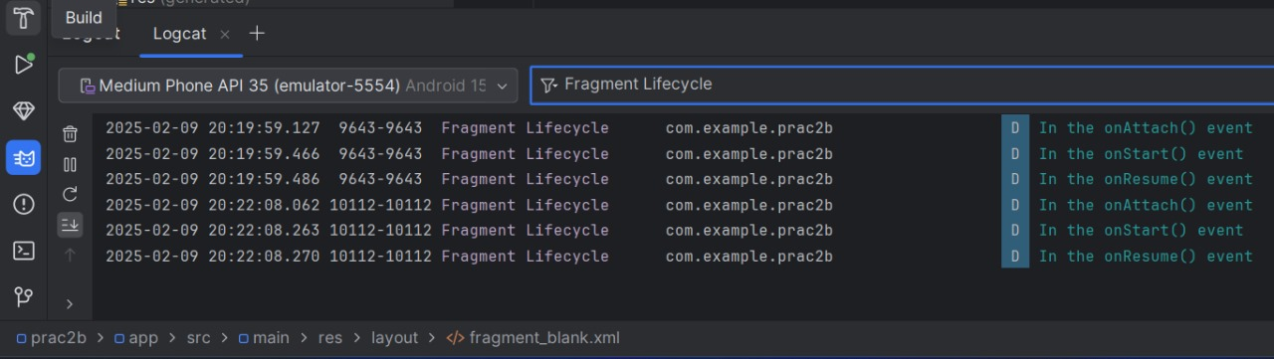

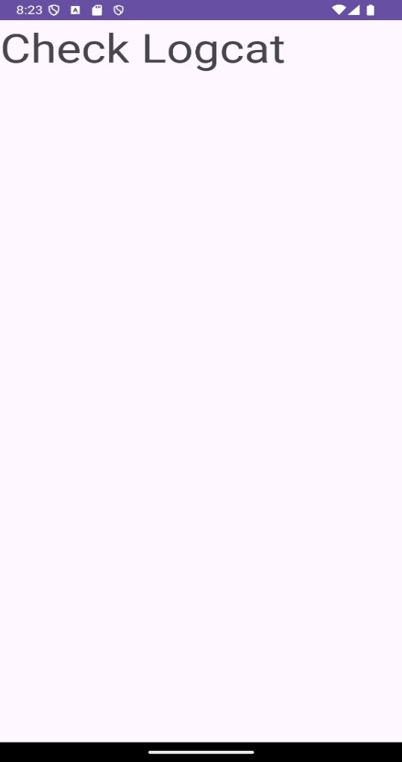

**Practical No 3**

1. **Relative Layout**

**activity_main.xml**

<?xml version="1.0" encoding="utf-8"?>  
<RelativeLayout xmlns:android="http://schemas.android.com/apk/res/android"  
 xmlns:app="http://schemas.android.com/apk/res-auto"  
 xmlns:tools="http://schemas.android.com/tools"  
 android:id="@+id/main"  
 android:layout_width="match_parent"  
 android:layout_height="match_parent"  
 tools:context=".MainActivity">  
 <TextView  
 android:id="@+id/lblComments"  
 android:layout_width="wrap_content"  
 android:layout_height="wrap_content"  
 android:text="Comments"  
 android:textSize="18sp"  
 android:layout_alignParentTop="true"  
 android:layout_alignParentLeft="true"  
 android:layout_marginLeft="16dp"  
 android:layout_marginTop="16dp"/>  
 <EditText  
 android:id="@+id/txtComments"  
 android:layout_width="match_parent"  
 android:layout_height="170dp"  
 android:textSize="18sp"  
 android:layout_below="@id/lblComments"  
 android:layout_marginTop="8dp"  
 android:layout_marginLeft="16dp"  
 android:layout_marginRight="16dp"  
 android:layout_centerHorizontal="true"  
 android:hint="Enter your comment"/>  
 <Button  
 android:id="@+id/btnShow"  
 android:layout_width="wrap_content"  
 android:layout_height="wrap_content"  
 android:text="Show"  
 android:layout_below="@id/txtComments"  
 android:layout_centerHorizontal="true"  
 android:layout_marginTop="16dp"  
 android:onClick="show"  
 tools:ignore="OnClick" /> <!-- Correct binding -->  
 <Button  
 android:id="@+id/btnClear"  
 android:layout_width="wrap_content"  
 android:layout_height="wrap_content"  
 android:text="Clear"  
 android:layout_below="@id/btnShow"  
 android:layout_centerHorizontal="true"  
 android:layout_marginTop="8dp"  
 android:onClick="clear"  
 tools:ignore="OnClick" /> <!-- Correct binding -->  
</RelativeLayout>

**MainActivity.java**

package com.example.practical3;  
import android.os.Bundle;  
import androidx.appcompat.app.AppCompatActivity;  
import android.os.Bundle;  
import android.view.View;  
import android.widget.EditText;  
import android.widget.Toast;  
public class MainActivity extends AppCompatActivity { @Override  
 protected void onCreate(Bundle savedInstanceState) {  
 super.onCreate(savedInstanceState);  
 setContentView(R.layout.*activity_main*); }  
 public void show(View view) {  
 EditText data = findViewById(R.id.*txtComments*);  
 String str = data.getText().toString();  
 Toast.*makeText*(this, str, Toast.*LENGTH_SHORT*).show();}  
 public void clear(View view) {  
 EditText data = findViewById(R.id.*txtComments*);  
 data.setText("");  
 Toast.*makeText*(this, "Text Cleared", Toast.*LENGTH_SHORT*).show();}}

**Output:**

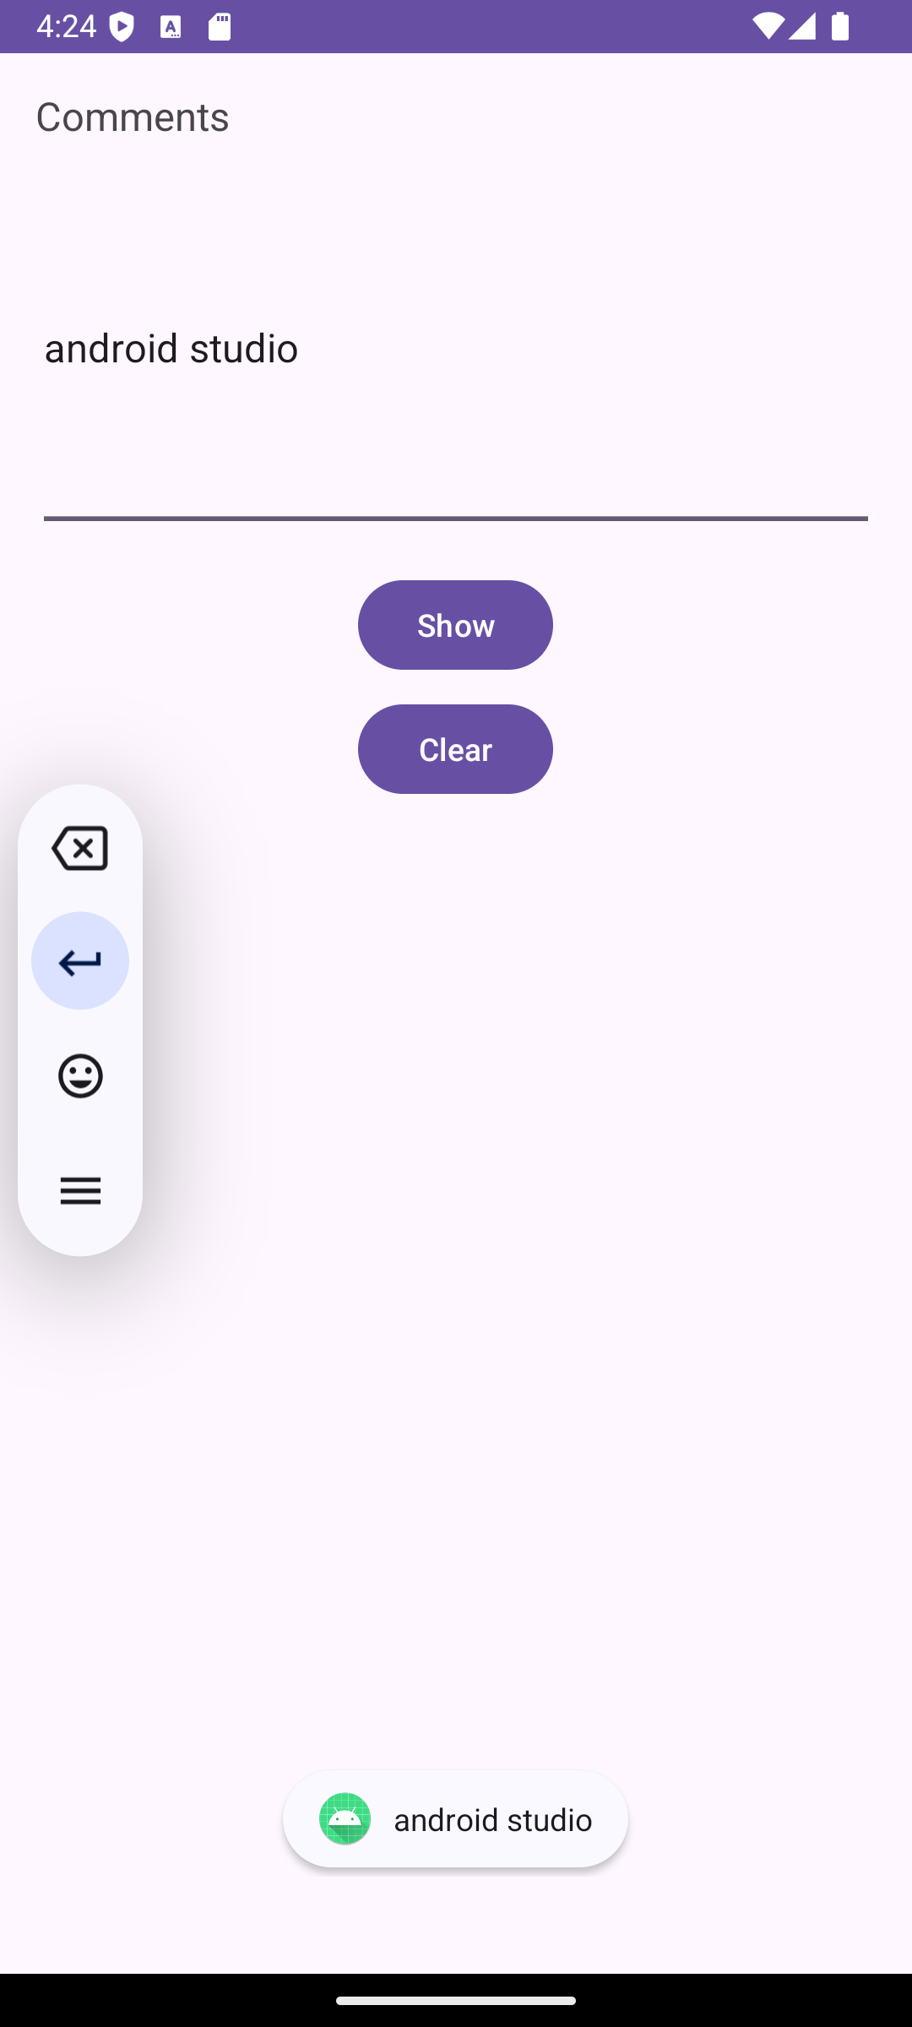 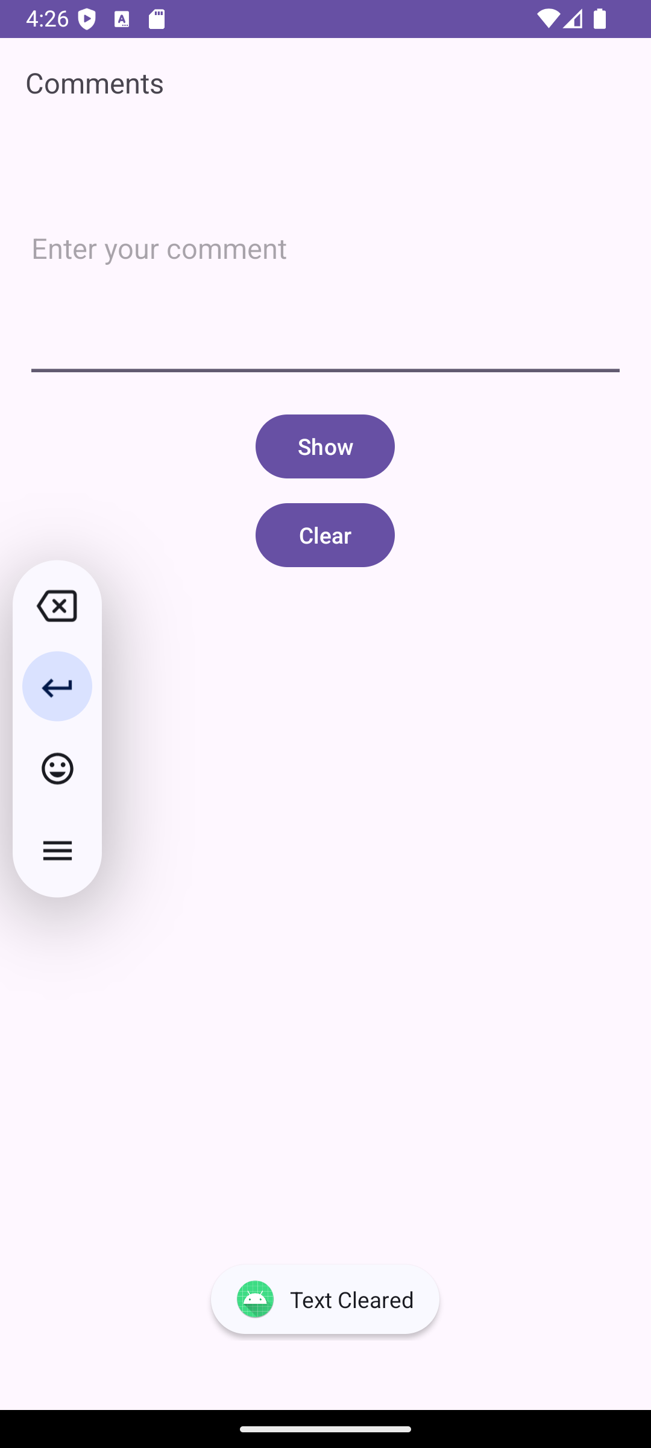

1. **Linear Layout**

**activity_main.xml**

<?xml version="1.0" encoding="utf-8"?>  
<LinearLayout  
 xmlns:android="http://schemas.android.com/apk/res/android"  
 xmlns:app="http://schemas.android.com/apk/res-auto"  
 xmlns:tools="http://schemas.android.com/tools"  
 android:id="@+id/main"  
 android:orientation="horizontal"  
 android:layout_width="match_parent"  
 android:layout_height="match_parent"  
 tools:context=".MainActivity">  
 <Button  
 android:layout_width="wrap_content"  
 android:layout_height="wrap_content"  
 android:id="@+id/b1"  
 android:onClick="button1"  
 android:text="@string/button1_text"/>  
 <Button  
 android:layout_width="wrap_content"  
 android:layout_height="wrap_content"  
 android:id="@+id/b2"  
 android:onClick="button2"  
 android:text="@string/button2_text"/>  
 <Button  
 android:layout_width="wrap_content"  
 android:layout_height="wrap_content"  
 android:id="@+id/b3"  
 android:onClick="button3"  
 android:text="@string/button3_text"/>  
 <Button  
 android:layout_width="wrap_content"  
 android:layout_height="wrap_content"  
 android:id="@+id/b4"  
 android:onClick="button4"  
 android:text="@string/button4_text"/>  
</LinearLayout>

**MainActivity.java**

package com.example.linearlayout;  
import android.os.Bundle;  
import android.view.View;  
import android.widget.Toast;  
import androidx.appcompat.app.AppCompatActivity;  
public class MainActivity extends AppCompatActivity {  
 @Override  
 protected void onCreate(Bundle savedInstanceState) {  
 super.onCreate(savedInstanceState);  
 setContentView(R.layout.*activity_main*); }  
 public void button1(View view) {  
 Toast.*makeText*(this, "This is Button 1", Toast.*LENGTH_SHORT*).show(); }  
 public void button2(View view) {  
 Toast.*makeText*(this, "This is Button 2", Toast.*LENGTH_SHORT*).show(); }  
 public void button3(View view) {  
 Toast.*makeText*(this, "This is Button 3", Toast.*LENGTH_SHORT*).show(); }  
 public void button4(View view) {  
 Toast.*makeText*(this, "This is Button 4", Toast.*LENGTH_SHORT*).show();  
 }  
}

**strings.xml**

<resources>  
 <string name="app_name">LinearLayout</string>  
 <string name="button1_text">Button 1</string>  
 <string name="button2_text">Button 2</string>  
 <string name="button3_text">Button 3</string>  
 <string name="button4_text">Button 4</string>  
</resources>

**Output:**

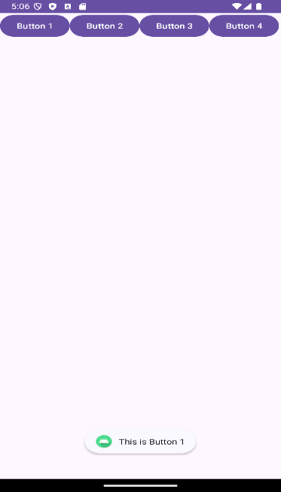 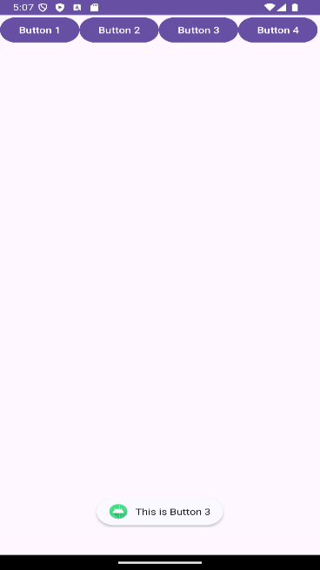 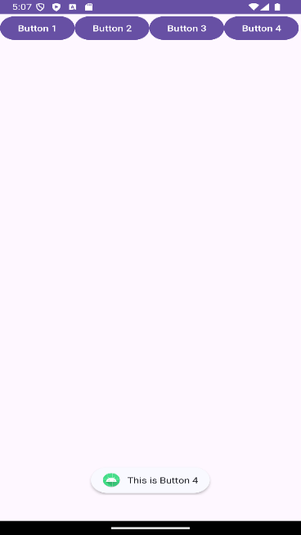

1. **VerticalLinearLayout**

**activity_main.xml**

<?xml version="1.0" encoding="utf-8"?>  
<LinearLayout  
 xmlns:android="http://schemas.android.com/apk/res/android"  
 xmlns:app="http://schemas.android.com/apk/res-auto"  
 xmlns:tools="http://schemas.android.com/tools"  
 android:id="@+id/main"  
 android:orientation="vertical"  
 android:layout_width="match_parent"  
 android:layout_height="match_parent"  
 android:gravity="center"  
 android:padding="16dp"  
 tools:context=".MainActivity">  
 <Button  
 android:id="@+id/b1"  
 android:layout_width="wrap_content"  
 android:layout_height="wrap_content"  
 android:onClick="button1"  
 android:text="Button 1"  
 android:padding="10dp"  
 android:layout_margin="10dp" />  
 <Button  
 android:id="@+id/b2"  
 android:layout_width="wrap_content"  
 android:layout_height="wrap_content"  
 android:onClick="button2"  
 android:text="Button 2"  
 android:padding="10dp"  
 android:layout_margin="10dp" />  
</LinearLayout>

**MainActivity.java**

package com.example.practical3;  
import android.os.Bundle;  
import android.view.View;  
import android.widget.Toast;  
import androidx.appcompat.app.AppCompatActivity;  
public class MainActivity extends AppCompatActivity {  
 @Override  
 protected void onCreate(Bundle savedInstanceState) {  
 super.onCreate(savedInstanceState);  
 setContentView(R.layout.*activity_main*);  
 }  
 public void button1(View view) {  
 Toast.*makeText*(this, "This is Button 1", Toast.*LENGTH_SHORT*).show();  
 }  
 public void button2(View view) {  
 Toast.*makeText*(this, "This is Button 2", Toast.*LENGTH_SHORT*).show();  
 }  
}

**Output:**

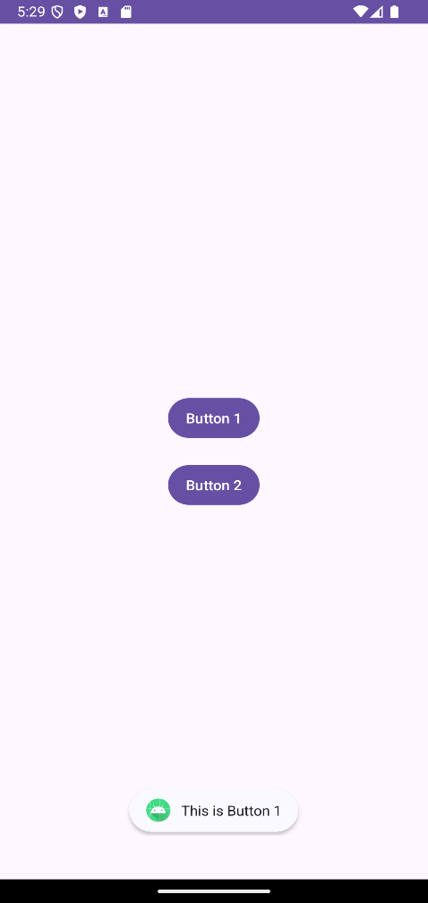 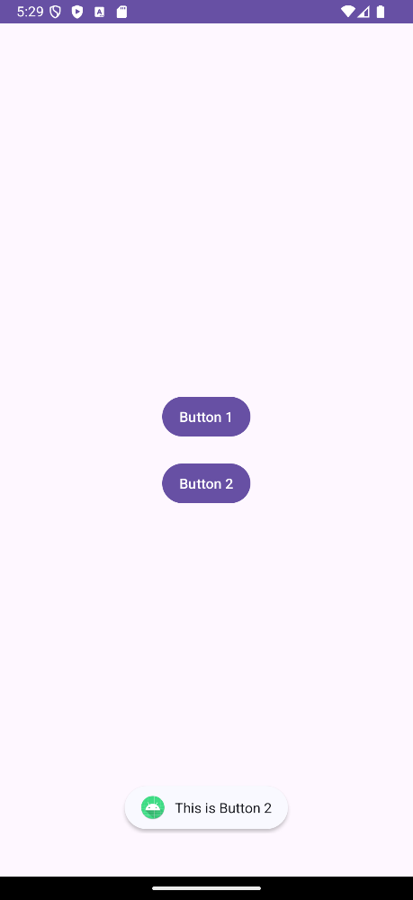

1. **TableLayout**

**activity_main.xml**

<?xml version=”1.0” encoding=”utf-8”?>

<TableLayout

Xmlns:android=<http://schemas.android.com/apk/res/android>

Xmlns:app=<http://schemas.android.com/apk/res-auto>

Xmlns:tools=<http://schemas.android.com/tools>

Android:id=”@+id/main”

Android:layout_width=”match_parent”

Android:layout_height=”match_parent”

Tools:context=”.MainActivity”>

<TableRow>

<TextView

Android:text=”User Name:”

Android:layout_width=”120dp”

Android:layout_height=”wrap_content”/>

<EditText

Android:id=”@+id/txtUserName”

Android:layout_width=”200dp”

Android:layout_height=”wrap_content”/>

</TableRow>

<TableRow>

<TextView

Android:text=”Password:”

Android:layout_width=”120dp”

Android:layout_height=”wrap_content”/>

<EditText

Android:id=”@+id/txtPassword”

Android:inputType=”textPassword”

Android:layout_width=”200dp”

Android:layout_height=”wrap_content”/>

</TableRow>

<TableRow>

<TextView />

<CheckBox

Android:id=”@+id/chkRememberPassword”

Android:layout_width=”wrap_content”

Android:layout_height=”wrap_content”

Android:text=”Remember Password”/>

</TableRow>

<TableRow>

<Button

Android:id=”@+id/buttonSignIn”

Android:onClick=”login”

Android:text=”Log In”/>

</TableRow>

</TableLayout>

**MainActivity.java**

Package com.example.table_layout;

Import android.os.Bundle;

Import android.view.View;

Import android.widget.EditText;

Import android.widget.Toast;

Import androidx.appcompat.app.AppCompatActivity;

Public class MainActivity extends AppCompatActivity { @Override

Protected void onCreate(Bundle savedInstanceState) {

Super.onCreate(savedInstanceState);

setContentView(R.layout.activity_main);}

Public void login(View view) {

// Correct the variable names

EditText txtUserName = findViewById(R.id.txtUserName);

EditText txtPassword = findViewById(R.id.txtPassword);

// Display user input with Toast

Toast.makeText(this, “User: “ + txtUserName.getText().toString() +

“\nPass: “ + txtPassword.getText().toString(), Toast.LENGTH_SHORT).show();}}

**Output:**

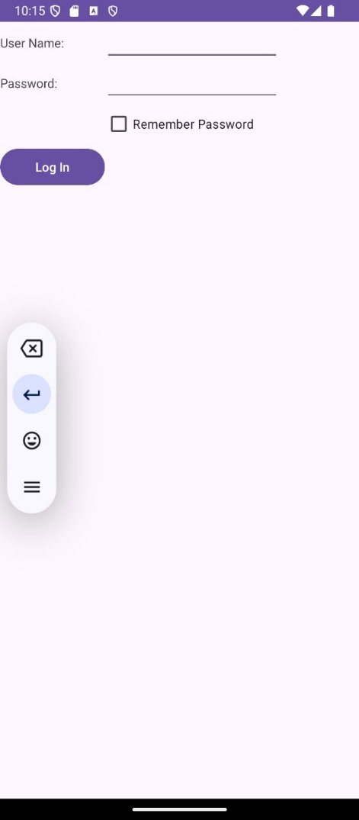 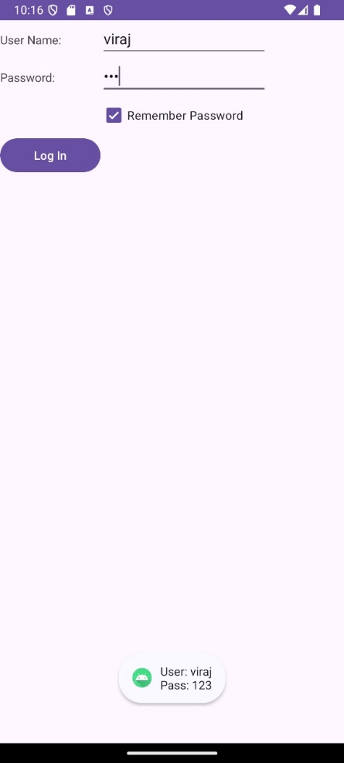

1. **Scroll Layout**

**activity_main.xml**

<?xml version="1.0" encoding="utf-8"?>  
<ScrollView xmlns:android="http://schemas.android.com/apk/res/android"  
 xmlns:app="http://schemas.android.com/apk/res-auto"  
 xmlns:tools="http://schemas.android.com/tools"  
 android:layout_width="match_parent"  
 android:layout_height="match_parent"

android:scrollbarSize="10dp"

tools:context=".MainActivity">  
<LinearLayout  
 android:layout_width="wrap_content"  
 android:layout_height="wrap_content"  
 android:orientation="vertical">  
 <TextView  
 android:layout_width="wrap_content"  
 android:layout_height="wrap_content"  
 android:text="Line1"  
 android:textSize="48dp"/>  
 <TextView  
 android:layout_width="wrap_content"  
 android:layout_height="wrap_content"  
 android:text="Line2"  
 android:textSize="48dp"/>  
 <TextView  
 android:layout_width="wrap_content"  
 android:layout_height="wrap_content"  
 android:text="Line3"  
 android:textSize="48dp"/>  
 <TextView  
 android:layout_width="wrap_content"  
 android:layout_height="wrap_content"  
 android:text="Line4"  
 android:textSize="48dp"/>  
 <TextView  
 android:layout_width="wrap_content"  
 android:layout_height="wrap_content"  
 android:text="Line5"  
 android:textSize="48dp"/>  
 <TextView  
 android:layout_width="wrap_content"  
 android:layout_height="wrap_content"  
 android:text="Line6"  
 android:textSize="48dp"/>  
 <TextView  
 android:layout_width="wrap_content"  
 android:layout_height="wrap_content"  
 android:text="Line7"  
 android:textSize="48dp"/>  
 <TextView  
 android:layout_width="wrap_content"  
 android:layout_height="wrap_content"  
 android:text="Line8"  
 android:textSize="48dp"/>  
 <TextView  
 android:layout_width="wrap_content"  
 android:layout_height="wrap_content"  
 android:text="Line9"  
 android:textSize="48dp"/>  
 <TextView  
 android:layout_width="wrap_content"  
 android:layout_height="wrap_content"  
 android:text="Line10"  
 android:textSize="48dp"/>  
 <TextView  
 android:layout_width="wrap_content"  
 android:layout_height="wrap_content"  
 android:text="Line11"  
 android:textSize="48dp"/>  
 <TextView  
 android:layout_width="wrap_content"  
 android:layout_height="wrap_content"  
 android:text="Line12"  
 android:textSize="48dp"/>  
 <TextView  
 android:layout_width="wrap_content"  
 android:layout_height="wrap_content"  
 android:text="Line13"  
 android:textSize="48dp"/>  
 <TextView  
 android:layout_width="wrap_content"  
 android:layout_height="wrap_content"  
 android:text="line14"  
 android:textSize="48dp"/>  
 <TextView  
 android:layout_width="wrap_content"  
 android:layout_height="wrap_content"  
 android:text="Line15"  
 android:textSize="48dp"/>  
 <TextView  
 android:layout_width="wrap_content"  
 android:layout_height="wrap_content"  
 android:text="Line16"  
 android:textSize="48dp"/>  
 <TextView  
 android:layout_width="wrap_content"  
 android:layout_height="wrap_content"  
 android:text="Line17"  
 android:textSize="48dp"/>  
</LinearLayout>  
</ScrollView>

**MainActivity.java** (No change)

package com.example.listview;  
import androidx.appcompat.app.AppCompatActivity;  
import android.os.Bundle;  
public class MainActivity extends AppCompatActivity {  
 @Override  
 protected void onCreate(Bundle savedInstanceState) {  
 super.onCreate(savedInstanceState);  
 setContentView(R.layout.*activity_main*);  
 }  
}

**Output:**

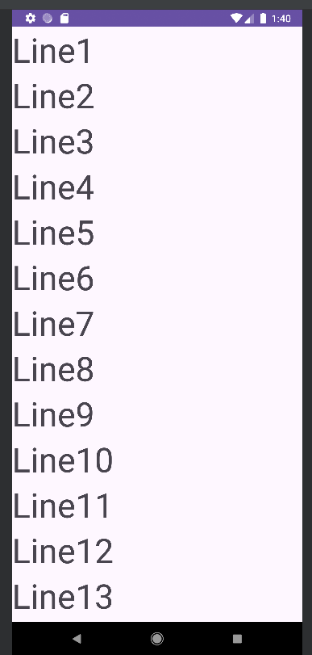 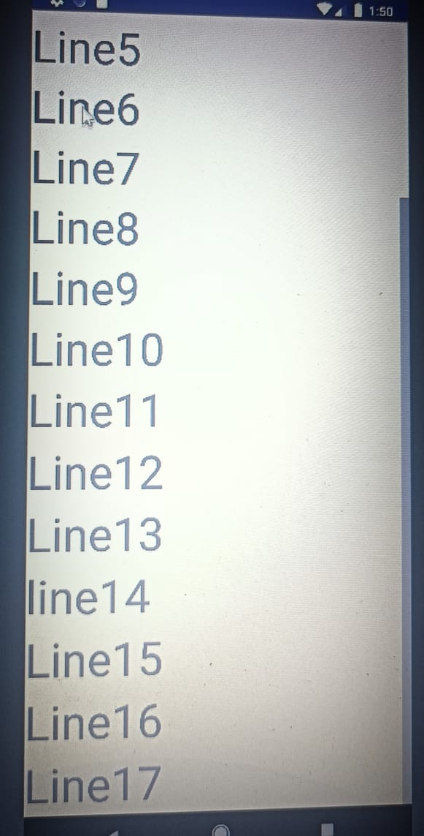

1. **Absolute Layout**

**activity_main.xml**

<?xml version="1.0" encoding="utf-8"?>  
<AbsoluteLayout  
 xmlns:android="http://schemas.android.com/apk/res/android"  
 xmlns:app="http://schemas.android.com/apk/res-auto"  
 xmlns:tools="http://schemas.android.com/tools"  
 android:layout_width="match_parent"  
 android:layout_height="match_parent"  
 tools:context=".MainActivity">  
 <Button  
 android:layout_width="188dp"  
 android:layout_height="wrap_content"  
 android:text="Button1"  
 android:layout_x="50px"  
 android:layout_y="30px"/>  
 <Button  
 android:layout_width="188dp"  
 android:layout_height="wrap_content"  
 android:text="Button2"  
 android:layout_x="200px"  
 android:layout_y="550px"/>  
 <Button  
 android:layout_width="188dp"  
 android:layout_height="wrap_content"  
 android:text="Button3"  
 android:layout_x="350px"  
 android:layout_y="740px"/>  
 <Button  
 android:layout_width="113dp"  
 android:layout_height="wrap_content"  
 android:text="Button4"  
 android:layout_x="12px"  
 android:layout_y="361px"/>  
</AbsoluteLayout>

**MainActivity.java**

package com.example.absolute_layout;  
import androidx.appcompat.app.AppCompatActivity;  
import android.os.Bundle;  
import android.widget.Toast;  
import android.view.View;  
public class MainActivity extends AppCompatActivity {  
 @Override  
 protected void onCreate(Bundle savedInstanceState) {  
 super.onCreate(savedInstanceState);  
 setContentView(R.layout.*activity_main*);  
 }  
 public void button1(View view)  
 {  
 Toast.*makeText*(this,"This is Button 1",Toast.*LENGTH_SHORT*).show();  
 }  
 public void button2(View view)  
 {  
 Toast.*makeText*(this,"This is Button 2",Toast.*LENGTH_SHORT*).show();  
 }  
 public void button3(View view)  
 {  
 Toast.*makeText*(this,"This is Button 3",Toast.*LENGTH_SHORT*).show();  
 }  
 public void button4(View view)  
 {  
 Toast.*makeText*(this,"This is Button 4",Toast.*LENGTH_SHORT*).show();  
 }  
}

**Output:**

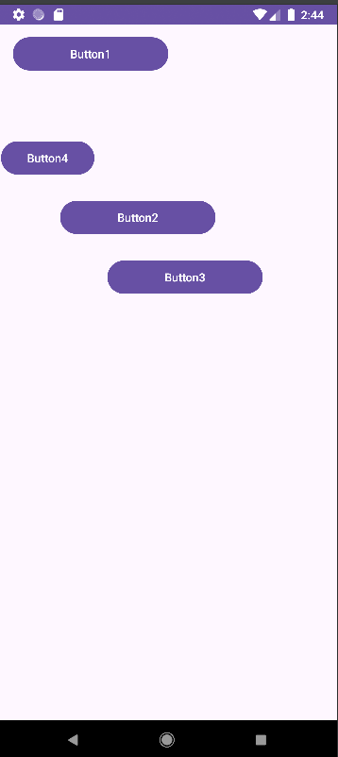

1. **ListView**

**activity_main.xml**

<?xml version="1.0" encoding="utf-8"?>  
<RelativeLayout  
 xmlns:android="http://schemas.android.com/apk/res/android"  
 xmlns:app="http://schemas.android.com/apk/res-auto"  
 xmlns:tools="http://schemas.android.com/tools"  
 android:layout_width="match_parent"  
 android:layout_height="match_parent"  
 tools:context=".MainActivity">  
 <TextView  
 android:layout_width="wrap_content"  
 android:layout_height="wrap_content"  
 android:text="ListView"  
 android:textSize="30dp"  
 android:layout_alignParentTop="true"  
 android:layout_centerHorizontal="true"  
 android:id="@+id/tvt"/>  
 <ListView  
 android:layout_width="wrap_content"  
 android:layout_height="wrap_content"  
 android:id="@+id/lv"  
 android:layout_below="@id/tvt"/>  
</RelativeLayout>

**MainActivity.java**

package com.example.practical3;  
import android.os.Bundle;  
import android.view.View;  
import android.widget.AdapterView;  
import android.widget.ArrayAdapter;  
import android.widget.EditText;  
import android.widget.ListView;  
import android.widget.Toast;  
import androidx.appcompat.app.AppCompatActivity;  
public class MainActivity extends AppCompatActivity {  
 ListView l;  
 @Override  
 protected void onCreate(Bundle savedInstanceState) {  
 super.onCreate(savedInstanceState);  
 setContentView(R.layout.*activity_main*);  
 final String[] s = {"Android", "iOS", "Windows", "Symbian", "Blackberry OS", "J2ME"};  
 l = findViewById(R.id.*lv*);  
 ArrayAdapter<String> ada = new ArrayAdapter<>(this, android.R.layout.*simple_list_item_1*, s);  
 l.setAdapter(ada);  
 l.setOnItemClickListener(new AdapterView.OnItemClickListener() {  
 @Override  
 public void onItemClick(AdapterView<?> parent, View view, int position, long id) {  
 Toast.*makeText*(getApplicationContext(), "Item clicked: " + position, Toast.*LENGTH_LONG*).show();  
 }});  
 }}

**Output:**

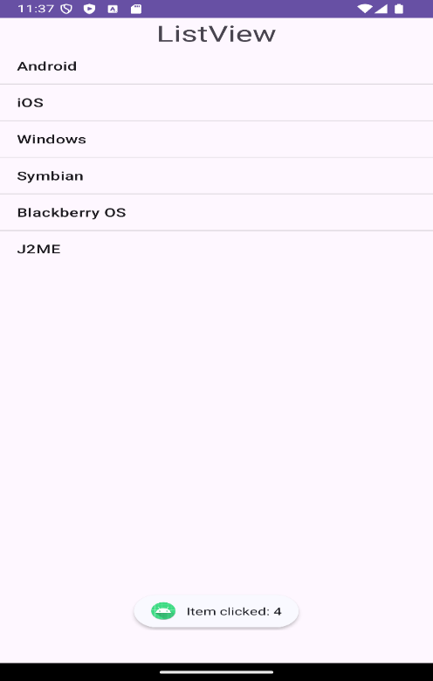 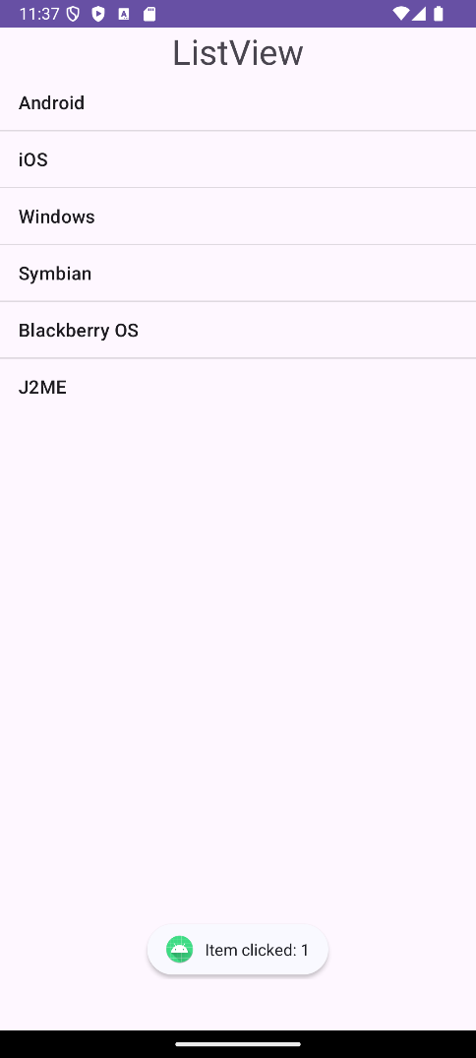

1. **Gridview**

**activity_main.xml**

<?xml version="1.0" encoding="utf-8"?>  
<LinearLayout xmlns:android="http://schemas.android.com/apk/res/android"  
 xmlns:app="http://schemas.android.com/apk/res-auto"  
 xmlns:tools="http://schemas.android.com/tools"  
 android:layout_width="match_parent"  
 android:layout_height="match_parent"  
 tools:context=".MainActivity">  
 <GridView  
 android:id="@+id/gridview"  
 android:layout_width="fill_parent"  
 android:layout_height="fill_parent"  
 android:numColumns="2"  
 android:verticalSpacing="10dp"  
 android:horizontalSpacing="10dp"  
 android:columnWidth="90dp"  
 android:stretchMode="columnWidth"  
android:gravity="center"/>  
</LinearLayout>

**MainActivity.java**

package com.example.gridview;  
import androidx.appcompat.app.AppCompatActivity;  
import android.content.Context;  
import android.os.Bundle;  
import android.view.View;  
import android.view.ViewGroup;  
import android.widget.AdapterView;  
import android.widget.BaseAdapter;  
import android.widget.GridView;  
import android.widget.ImageView;  
import android.widget.Toast;  
public class MainActivity extends AppCompatActivity {  
 Integer[] imageIDs = {  
 R.mipmap.*ic_launcher*,  
 R.mipmap.*ic_launcher*,  
 R.mipmap.*ic_launcher*,  
 R.mipmap.*ic_launcher*,  
 R.mipmap.*ic_launcher*,  
 R.mipmap.*ic_launcher*,  
 R.mipmap.*ic_launcher* };  
 @Override  
 protected void onCreate(Bundle savedInstanceState) {  
 super.onCreate(savedInstanceState);  
 setContentView(R.layout.*activity_main*);  
 GridView gridView = (GridView) findViewById(R.id.*gridview*);  
 gridView.setAdapter(new ImageAdapter(this));  
 gridView.setOnItemClickListener(new AdapterView.OnItemClickListener() {  
 public void onItemClick(AdapterView<?> parent, View v, int position, long id) {  
 Toast.*makeText*(getBaseContext(),  
 "pic" + (position + 1) + " selected",  
 Toast.*LENGTH_SHORT*).show();  
 }  
 });  
 }  
 public class ImageAdapter extends BaseAdapter {  
 private Context context;  
 public ImageAdapter(Context c) {  
 context = c;  
 }  
 public int getCount() {  
 return imageIDs.length;  
 }  
 public Object getItem(int position) {  
 return position;  
 }  
 public long getItemId(int position) {  
 return position;  
 }  
 public View getView(int position, View convertView, ViewGroup parent) {  
 ImageView imageView;  
 if (convertView == null) {  
 imageView = new ImageView(context);  
 imageView.setLayoutParams(new ViewGroup.LayoutParams(85, 85));  
 imageView.setScaleType(ImageView.ScaleType.*CENTER_CROP*);  
 imageView.setPadding(5, 5, 5, 5);  
 } else {  
 imageView = (ImageView) convertView;  
 }  
 imageView.setImageResource(imageIDs[position]);  
 return imageView;  
 }  
 }  
}

**Output:**

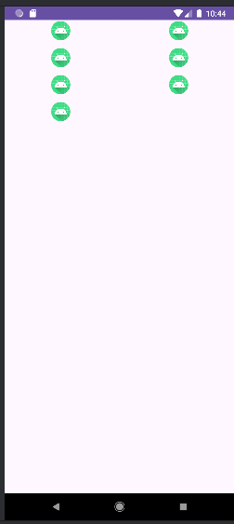

**Practical No 4**

**Practical 4A**

**Aim:** Programming UI elements: App Bar

**activity_main.xml**

<?xml version="1.0" encoding="utf-8"?>  
<LinearLayout xmlns:android="http://schemas.android.com/apk/res/android"  
 xmlns:app="http://schemas.android.com/apk/res-auto"  
 xmlns:tools="http://schemas.android.com/tools"  
 android:layout_width="match_parent"  
 android:layout_height="match_parent"  
 android:orientation="vertical"  
 tools:context=".MainActivity">  
 <!-- Toolbar at the top -->  
 <androidx.appcompat.widget.Toolbar  
 android:id="@+id/toolbar"  
 android:layout_width="match_parent"  
 android:layout_height="?attr/actionBarSize"  
 android:background="?attr/colorPrimary"  
 android:elevation="4dp"  
 android:theme="@style/ThemeOverlay.AppCompat.Dark.ActionBar"  
 app:title="Simple AppBar" />  
 <!-- Other UI elements can go below -->  
 <!-- For example, a content area -->  
</LinearLayout>

**MainActivity.java**

package com.example.appbar;  
import androidx.annotation.NonNull;  
import androidx.appcompat.app.AppCompatActivity;  
import android.graphics.Color;  
import android.os.Bundle;  
import android.text.SpannableString;  
import android.text.style.ForegroundColorSpan;  
import android.view.Menu;  
import android.view.MenuItem;  
import android.widget.Toast;  
import androidx.appcompat.widget.Toolbar;  
public class MainActivity extends AppCompatActivity {  
 @Override  
 protected void onCreate(Bundle savedInstanceState) {  
 super.onCreate(savedInstanceState);  
 setContentView(R.layout.*activity_main*);  
 Toolbar toolbar = findViewById(R.id.*toolbar*);  
 setSupportActionBar(toolbar);  
 }  
 @Override  
 public boolean onCreateOptionsMenu(Menu menu) {  
 getMenuInflater().inflate(R.menu.*menu_main*, menu);  
 return true;  
 }  
 @Override  
 public boolean onPrepareOptionsMenu(Menu menu) {  
 for (int i = 0; i < menu.size(); i++) {  
 MenuItem item = menu.getItem(i);  
 SpannableString s = new SpannableString(item.getTitle());  
 s.setSpan(new ForegroundColorSpan(Color.*BLACK*), 0, s.length(), 0);  
 item.setTitle(s);  
 }  
 return super.onPrepareOptionsMenu(menu);  
 }  
 @Override  
 public boolean onOptionsItemSelected(MenuItem item) {  
 int id = item.getItemId();  
 if (id == R.id.*action_settings*) {  
 Toast.*makeText*(this, "Settings Clicked", Toast.*LENGTH_SHORT*).show();  
 return true;  
 }  
 if (id == R.id.*action_settings1*) {  
 Toast.*makeText*(this, "Settings1 Clicked", Toast.*LENGTH_SHORT*).show();  
 return true;  
 }  
 return super.onOptionsItemSelected(item);  
 }  
}

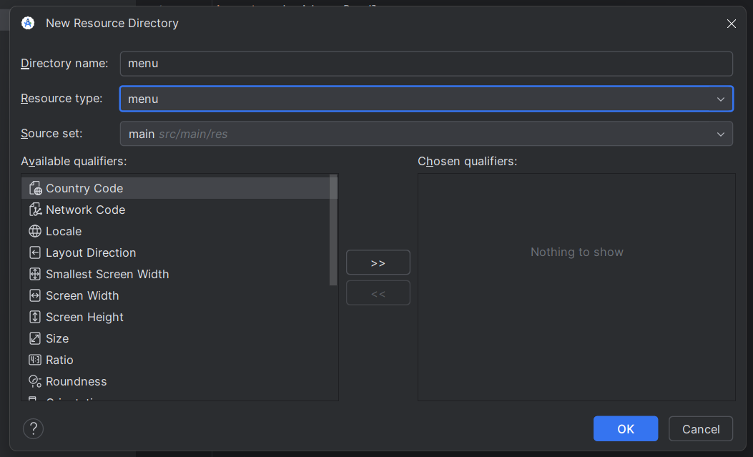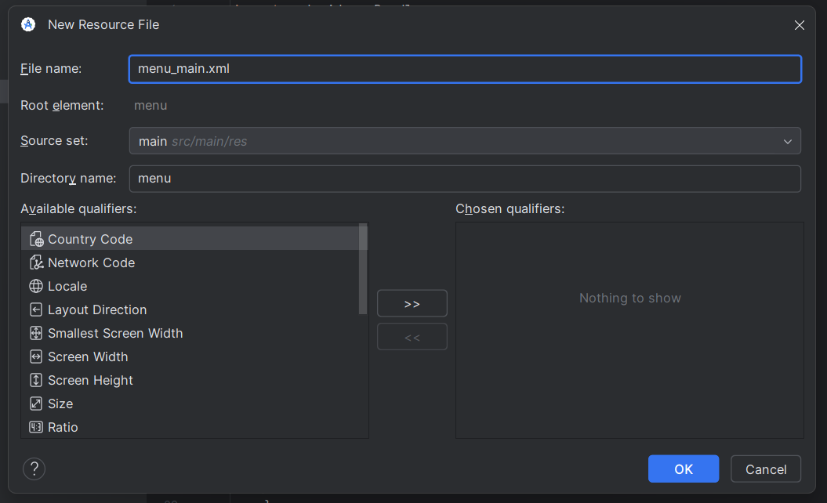

**menu_main.xml**

<?xml version="1.0" encoding="utf-8"?>  
<menu xmlns:android="http://schemas.android.com/apk/res/android"  
 xmlns:app="http://schemas.android.com/apk/res-auto">  
 <!-- Menu item 1 -->  
 <item  
 android:id="@+id/action_settings"  
 android:title="Settings"  
 android:orderInCategory="100" />  
 <!-- Menu item 2 -->  
 <item  
 android:id="@+id/action_settings1"  
 android:title="Settings1"  
 android:orderInCategory="100" />  
</menu>

**Output:**

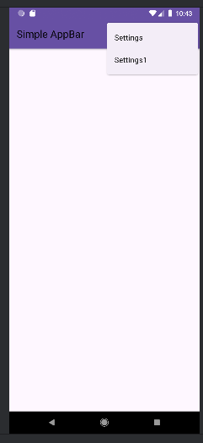 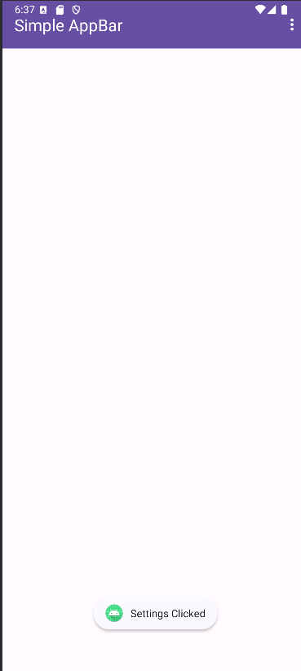

**Practical 4B**

**Aim:** Programming Elements: Fragment

**activity_main.xml**

<?xml version="1.0" encoding="utf-8"?>

<LinearLayout xmlns:android="http://schemas.android.com/apk/res/android" xmlns:app=<http://schemas.android.com/apk/res-auto>

xmlns:tools=<http://schemas.android.com/tools>

android:id="@+id/main"

android:layout_width="match_parent"

android:layout_height="match_parent"

tools:context=".MainActivity">

<Button

android:id="@+id/button_load_fragment"

android:layout_width="wrap_content"

android:layout_height="wrap_content"

android:text="Load Fragment"/>

<FrameLayout

android:id="@+id/fragment_container"

android:layout_width="match_parent"

android:layout_height="match_parent"

android:layout_marginTop="16dp"/>

</LinearLayout>

**MainActivity.java**

package com.example.prac4b;

import android.os.Bundle;

import android.view.View;

import android.widget.Button;

import androidx.appcompat.app.AppCompatActivity;

import androidx.fragment.app.Fragment;

import androidx.fragment.app.FragmentManager;

import androidx.fragment.app.FragmentTransaction;

public class MainActivity extends AppCompatActivity {

@Override

protected void onCreate(Bundle savedInstanceState) {

super.onCreate(savedInstanceState);

setContentView(R.layout.activity_main);

Button buttonLoadFragment = findViewById(R.id.button_load_fragment);

buttonLoadFragment.setOnClickListener(new View.OnClickListener() {

@Override

public void onClick(View v) {

loadFragment(new BlankFragment());

} }); }

private void loadFragment(Fragment fragment) {

// Create a FragmentManager

FragmentManager fragmentManager = getSupportFragmentManager();

// Create a FragmentTransaction to begin the transaction and replace the Fragment

FragmentTransaction fragmentTransaction = fragmentManager.beginTransaction();

fragmentTransaction.replace(R.id.fragment_container, fragment);

// Commit the transaction

fragmentTransaction.commit();

    }}

**fragment_blank.xml**

<?xml version="1.0" encoding="utf-8"?>

<LinearLayout xmlns:android="http://schemas.android.com/apk/res/android"

xmlns:tools="http://schemas.android.com/tools"

android:layout_width="match_parent"

android:layout_height="match_parent"

android:orientation='horizontal'

android:gravity="center">

<TextView

android:id="@+id/textView_fragment"

android:layout_width="match_parent"

android:layout_height="match_parent"

android:text="@string/hello_blank_fragment"

android:textSize="18sp"/>

</LinearLayout>

**BlankFragment.java**

package com.example.prac4b;

import android.os.Bundle;

import androidx.annotation.NonNull;

import androidx.annotation.Nullable;

import androidx.fragment.app.Fragment;

import android.view.LayoutInflater;

import android.view.View;

import android.view.ViewGroup;

public class BlankFragment extends Fragment {

@Nullable

@Override

public View onCreateView(@NonNull LayoutInflater inflater,@Nullable ViewGroup container, @Nullable Bundle savedInstanceState) {

// Inflate the layout for this fragment

return inflater.inflate(R.layout.fragment_blank, container, false);

    }}

**Output:**

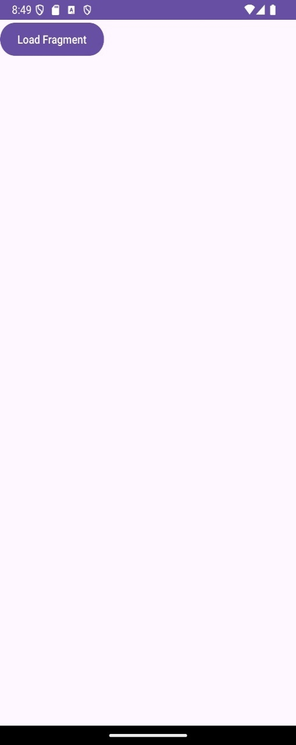 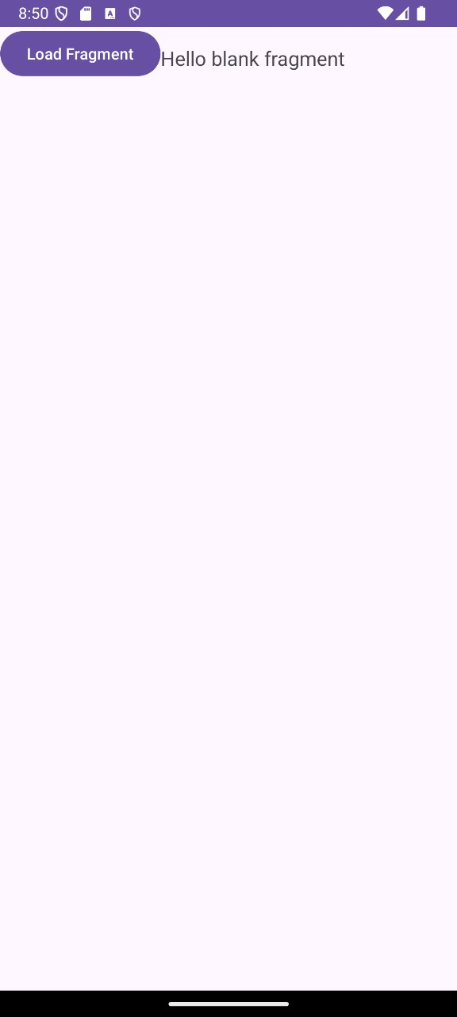

**Practical 4C**

**Aim:** Programming UI elements : UI Components

**activity_main.xml**

<?xml version="1.0" encoding="utf-8"?>  
<LinearLayout xmlns:android="http://schemas.android.com/apk/res/android"  
 xmlns:app="http://schemas.android.com/apk/res-auto"  
 xmlns:tools="http://schemas.android.com/tools"  
 android:layout_width="match_parent"  
 android:layout_height="match_parent"  
 android:orientation="vertical"  
 tools:context=".MainActivity">  
 <Button  
 android:layout_width="match_parent"  
 android:layout_height="wrap_content"  
 android:id="@+id/btnSave"  
 android:text="Save"  
 android:layout_alignParentTop="true"/>  
 <ImageButton  
 android:layout_width="wrap_content"  
 android:layout_height="wrap_content"  
 android:id="@+id/ib"  
 android:src="@mipmap/ic_launcher"/>  
 <EditText  
 android:layout_width="wrap_content"  
 android:layout_height="wrap_content"  
 android:hint="edit text"  
 android:id="@+id/et"/>  
 <CheckBox  
 android:layout_width="wrap_content"  
 android:layout_height="wrap_content"  
 android:id="@+id/cb1"  
 android:text="Auto Save"/>  
 <CheckBox  
 android:layout_width="wrap_content"  
 android:layout_height="wrap_content"  
 android:id="@+id/cbst"  
 android:text=""  
 style="?android:attr/starStyle"/>  
 <RadioGroup  
 android:layout_width="wrap_content"  
 android:layout_height="wrap_content"  
 android:id="@+id/rg">  
 <RadioButton  
 android:layout_width="wrap_content"  
 android:layout_height="wrap_content"  
 android:id="@+id/rb1"  
 android:text="Option1"/>  
 <RadioButton  
 android:layout_width="wrap_content"  
 android:layout_height="wrap_content"  
 android:id="@+id/rb2"  
 android:text="Option2"/>  
 </RadioGroup>  
 <ToggleButton  
 android:layout_width="wrap_content"  
 android:layout_height="wrap_content"  
 android:id="@+id/tb"/>  
</LinearLayout>

**MainActivity.java**

package com.example.uicomponents;  
import androidx.appcompat.app.AppCompatActivity;  
import android.os.Bundle;  
import android.view.Display;  
import android.view.View;  
import android.widget.Button;  
import android.widget.CheckBox;  
import android.widget.CompoundButton;  
import android.widget.EditText;  
import android.widget.ImageButton;  
import android.widget.RadioButton;  
import android.widget.ToggleButton;  
import android.widget.Toast;  
public class MainActivity extends AppCompatActivity {  
 @Override  
 protected void onCreate(Bundle savedInstanceState) {  
 super.onCreate(savedInstanceState);  
 setContentView(R.layout.*activity_main*);  
 Button btsave=(Button) findViewById(R.id.*btnSave*);  
 ImageButton imgb=(ImageButton) findViewById(R.id.*ib*);  
 EditText etext=(EditText) findViewById(R.id.*et*);  
 CheckBox cb1=(CheckBox) findViewById(R.id.*cb1*);  
 CheckBox cbst=(CheckBox) findViewById(R.id.*cbst*);  
 RadioButton rb1=(RadioButton) findViewById(R.id.*rb1*);  
 RadioButton rb2=(RadioButton) findViewById(R.id.*rb2*);  
 ToggleButton tbutton =(ToggleButton) findViewById(R.id.*tb*);  
 btsave.setOnClickListener(new View.OnClickListener()  
 {  
 @Override  
 public void onClick(View v)  
 {  
 DisplayToast("Save Button clicked");  
 }  
 });  
 imgb.setOnClickListener(new View.OnClickListener() {  
 @Override  
 public void onClick(View v) {  
 DisplayToast("ImageButton Clicked");  
 }  
 });  
 cb1.setOnClickListener(new View.OnClickListener() {  
 @Override  
 public void onClick(View v) {  
 if(((CheckBox)v).isChecked())  
 DisplayToast("CheckBox Option1 is checked");  
 else  
 DisplayToast(" CheckBox unchecked");  
 }  
 });  
 cbst.setOnClickListener(new View.OnClickListener() {  
 @Override  
 public void onClick(View v) {  
 if(((CheckBox)v).isChecked())  
 DisplayToast("CheckBox Option2 is checked");  
 else  
 DisplayToast(" CheckBox unchecked");  
 }  
 });  
 cbst.setOnClickListener(new View.OnClickListener() {  
 @Override  
 public void onClick(View v) {  
 if(((CheckBox)v).isChecked())  
 DisplayToast("CheckBox Option2 is checked");  
 else  
 DisplayToast(" CheckBox unchecked");  
 }  
 });  
 rb1.setOnCheckedChangeListener(new CompoundButton.OnCheckedChangeListener()  
 {  
 @Override  
 public void onCheckedChanged(CompoundButton buttonView,boolean ischecked)  
 {  
 if(rb1.isChecked()) {  
 DisplayToast("RadioButton 1 is checked");  
 }  
 else  
 DisplayToast("RadioButton 1 is unchecked");  
 }  
 });  
 rb2.setOnCheckedChangeListener(new CompoundButton.OnCheckedChangeListener()  
 {  
 @Override  
 public void onCheckedChanged(CompoundButton buttonView,boolean ischecked)  
 {  
 if(rb2.isChecked()) {  
 DisplayToast("RadioButton 2 is checked");  
 }  
 else  
 DisplayToast("RadioButton 2 is unchecked");  
 }  
 });  
 tbutton.setOnClickListener(new View.OnClickListener() {  
 @Override  
 public void onClick(View v) {  
 if(tbutton.isChecked()) {  
 DisplayToast("ToggleButton is on");  
 }  
 else  
 DisplayToast("ToggleButton is off");  
 }  
 }); }  
 public void DisplayToast(String s)  
 {  
 Toast.*makeText*(this,s,Toast.*LENGTH_SHORT*).show();  
 }}

**Output:**

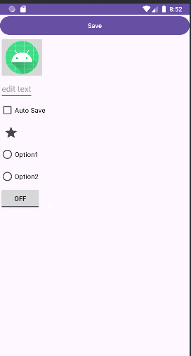

**Practical 5**

**Practical 5A**

**Aim:** Creating Menus

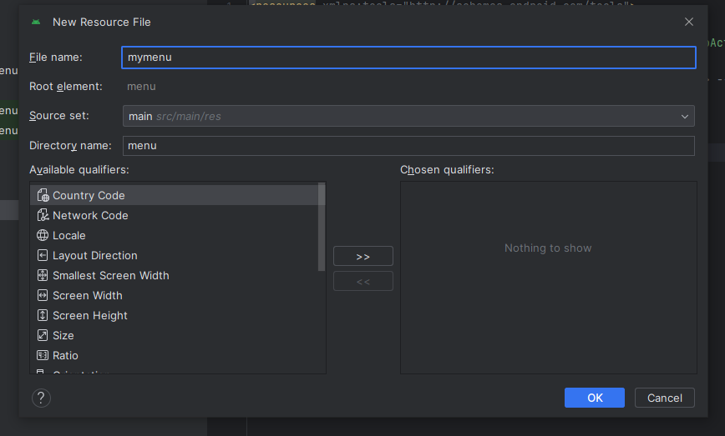

**themes.xml**

<resources xmlns:tools="http://schemas.android.com/tools">  
 <!-- Base application theme. -->  
 <style name="Base.Theme.Menu" parent="Theme.AppCompat.Light.DarkActionBar">  
 <!-- Customize your light theme here. -->  
 <!-- <item name="colorPrimary">@color/my_light_primary</item> -->  
 </style>  
 <style name="Theme.Menu" parent="Base.Theme.Menu" />  
</resources>

**Mymenu.xml**

<?xml version="1.0" encoding="utf-8"?>  
<menu xmlns:android="http://schemas.android.com/apk/res/android">  
<item  
 android:id="@+id/newb"  
 android:title="Bookmarks"/>  
 <item  
 android:id="@+id/search"  
 android:title="Search"/>  
 <item  
 android:id="@+id/save"  
 android:title="Save"/>  
 <item  
 android:id="@+id/Share"  
 android:title="Share"/>  
 <item  
 android:id="@+id/delete"  
 android:title="Delete"/>  
 <item  
 android:id="@+id/exit"  
 android:title="exit"/>  
</menu>

**MainActivity.java**

package com.example.menu;  
import androidx.appcompat.app.AppCompatActivity;  
import android.os.Bundle;  
import android.view.Menu;  
import android.view.MenuInflater;  
public class MainActivity extends AppCompatActivity {  
 @Override  
 protected void onCreate(Bundle savedInstanceState) {  
 super.onCreate(savedInstanceState);  
 setContentView(R.layout.*activity_main*);  
 } @Override  
 public boolean onCreateOptionsMenu(Menu menu) {  
 // Inflating the menu resource file  
 MenuInflater mi = getMenuInflater();  
 mi.inflate(R.menu.*mymenu*, menu);  
 return true;  
 }

}

**Output:**

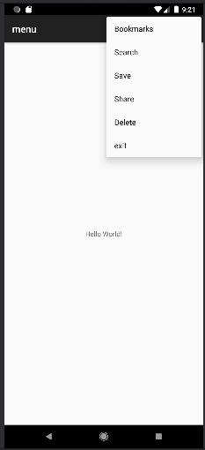

**Practical 5B**

**Aim:** Creating Dialog

**activity_main.xml**

<?xml version="1.0" encoding="utf-8"?>  
<LinearLayout  
 xmlns:android="http://schemas.android.com/apk/res/android"  
 android:layout_width="match_parent"  
 android:layout_height="match_parent"  
 android:orientation="vertical"  
 android:padding="20dp">  
 <Button  
 android:id="@+id/button_dialog"  
 android:layout_width="match_parent"  
 android:layout_height="wrap_content"  
 android:onClick="onClickDialog"  
 android:text="Click to display an AlertDialog" />  
 <Button  
 android:id="@+id/button_progressdialog"  
 android:layout_width="match_parent"  
 android:layout_height="wrap_content"  
 android:onClick="onClickProgressDialog"  
 android:text="Click to display a ProgressDialog" />  
 <Button  
 android:id="@+id/button_datedialog"  
 android:layout_width="match_parent"  
 android:layout_height="wrap_content"  
 android:onClick="onClickDateDialog"  
 android:text="Click to display a DatePickerDialog" />  
 <Button  
 android:id="@+id/button_timedialog"  
 android:layout_width="match_parent"  
 android:layout_height="wrap_content"  
 android:onClick="onClickTimeDialog"  
 android:text="Click to display a TimePickerDialog" />  
 <TextView  
 android:id="@+id/textView_date"  
 android:layout_width="match_parent"  
 android:layout_height="wrap_content"  
 android:text="Selected Date:"  
 android:textSize="20sp"  
 android:paddingTop="10dp"/>  
 <TextView  
 android:id="@+id/textView_time"  
 android:layout_width="match_parent"  
 android:layout_height="wrap_content"  
 android:text="Selected Time:"  
 android:textSize="20sp"  
 android:paddingTop="10dp"/>  
</LinearLayout>

**MainActivity.java**

package com.example.practical5b;  
import android.app.AlertDialog;  
import android.app.DatePickerDialog;  
import android.app.ProgressDialog;  
import android.app.TimePickerDialog;  
import android.content.DialogInterface;  
import android.os.Bundle;  
import android.view.View;  
import android.widget.DatePicker;  
import android.widget.TextView;  
import android.widget.TimePicker;  
import android.widget.Toast;  
import androidx.appcompat.app.AppCompatActivity;  
import java.util.Calendar;  
public class MainActivity extends AppCompatActivity {  
 CharSequence[] items = {"Android", "Security", "Cloud"};  
 boolean[] itemsChecked = new boolean[items.length];  
 @Override  
 protected void onCreate(Bundle savedInstanceState) {  
 super.onCreate(savedInstanceState);  
 setContentView(R.layout.*activity_main*);  
 }  
 public void onClickDialog(View v) {  
 AlertDialog.Builder builder = new AlertDialog.Builder(this);  
 builder.setTitle("This is a dialog with simple Text...");  
 builder.setPositiveButton("OK", (dialog, id) ->  
 Toast.*makeText*(getBaseContext(), "OK Clicked", Toast.*LENGTH_SHORT*).show());  
 builder.setNegativeButton("CANCEL", (dialog, id) ->  
 Toast.*makeText*(getBaseContext(), "CANCEL Clicked", Toast.*LENGTH_SHORT*).show());  
 builder.setMultiChoiceItems(items, itemsChecked, (dialog, id, isChecked) ->  
 Toast.*makeText*(getBaseContext(), items[id] + (isChecked ? " checked" : " unchecked"),  
 Toast.*LENGTH_SHORT*).show());  
 builder.show();  
 }  
 public void onClickProgressDialog(View v) {  
 ProgressDialog pDialog = new ProgressDialog(this);  
 pDialog.setProgressStyle(ProgressDialog.*STYLE_HORIZONTAL*);  
 pDialog.setMessage("Loading.....");  
 pDialog.setMax(100);  
 pDialog.setProgress(0);  
 pDialog.setCancelable(false);  
 pDialog.setButton(DialogInterface.*BUTTON_POSITIVE*, "STOP PROGRESS", (dialog, id) -> pDialog.dismiss());  
 pDialog.show();  
 // Simulate progress update  
 new Thread(() -> {  
 try {  
 for (int i = 0; i <= 100; i += 10) {  
 Thread.*sleep*(500); // Simulate loading time  
 int finalI = i;  
 runOnUiThread(() -> pDialog.setProgress(finalI));  
 }  
 pDialog.dismiss();  
 } catch (InterruptedException e) {  
 e.printStackTrace();  
 }  
 }).start();  
 }  
 public void onClickDateDialog(View v) {  
 final TextView dateDisplay = findViewById(R.id.*textView_date*);  
 final Calendar c = Calendar.*getInstance*();  
 int mYear = c.get(Calendar.*YEAR*);  
 int mMonth = c.get(Calendar.*MONTH*);  
 int mDay = c.get(Calendar.*DAY_OF_MONTH*);  
 DatePickerDialog dateDialog = new DatePickerDialog(this,  
 (view, year, month, day) ->  
 dateDisplay.setText("Selected Date: " + (month + 1) + "-" + day + "-" + year),  
 mYear, mMonth, mDay);  
 dateDialog.show();  
 }  
 public void onClickTimeDialog(View v) {  
 final TextView timeDisplay = findViewById(R.id.*textView_time*);  
 final Calendar c = Calendar.*getInstance*();  
 int mHour = c.get(Calendar.*HOUR_OF_DAY*);  
 int mMinute = c.get(Calendar.*MINUTE*);  
 TimePickerDialog timeDialog = new TimePickerDialog(this,  
 (view, hour, minute) ->  
 timeDisplay.setText("Selected Time: " + hour + ":" + String.*format*("%02d", minute)),  
 mHour, mMinute, true);  
 timeDialog.show();  
 }  
}

**Output:**

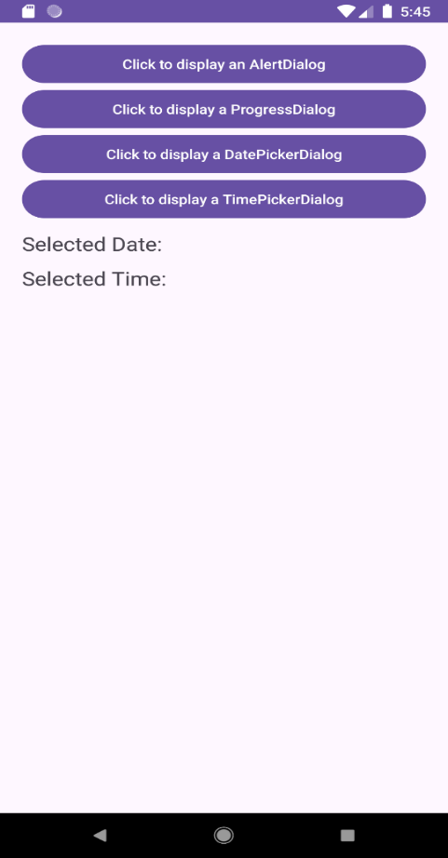 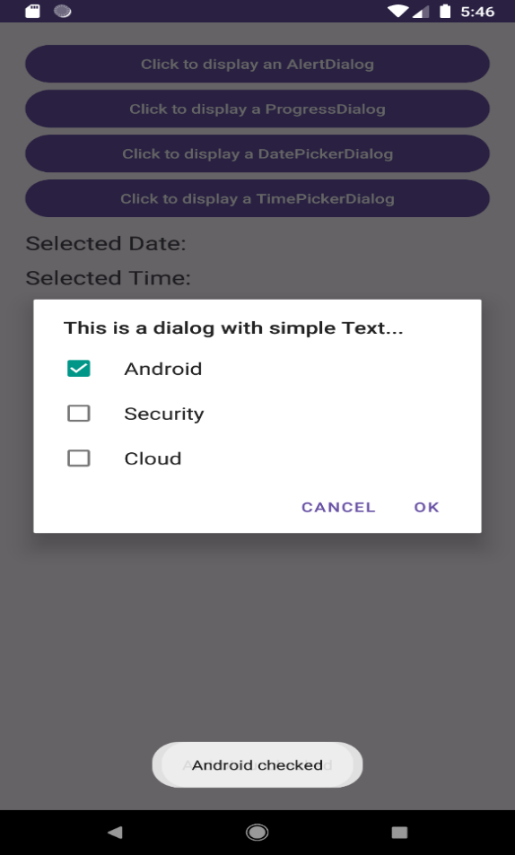

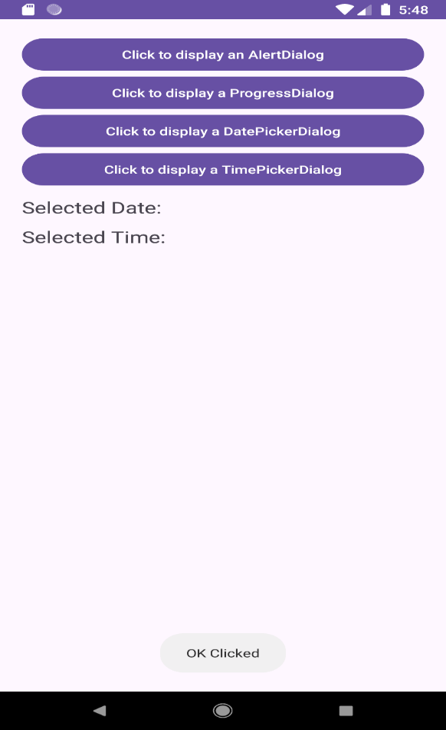 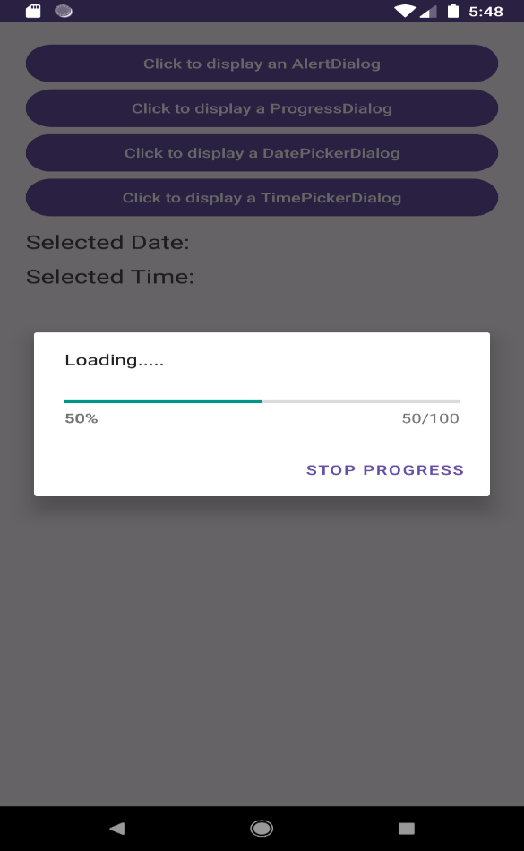

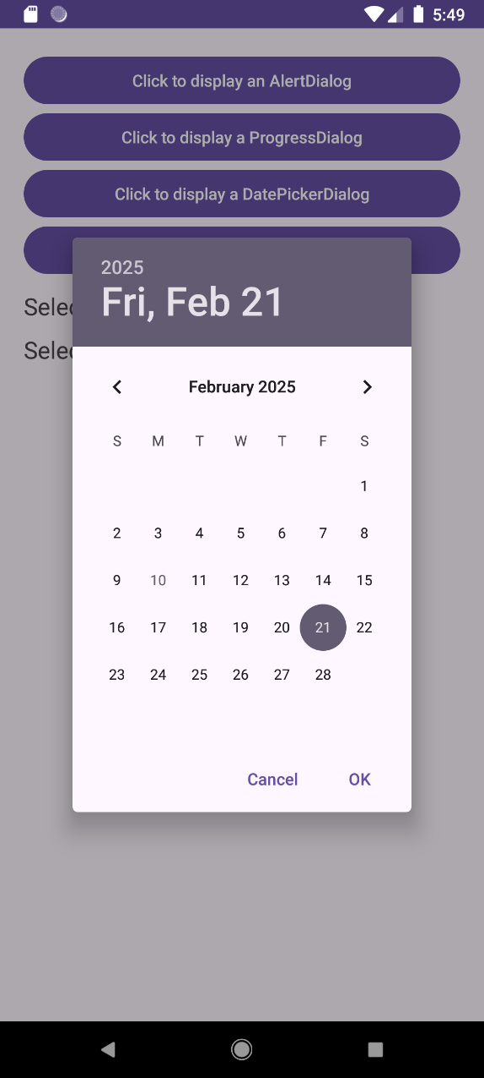 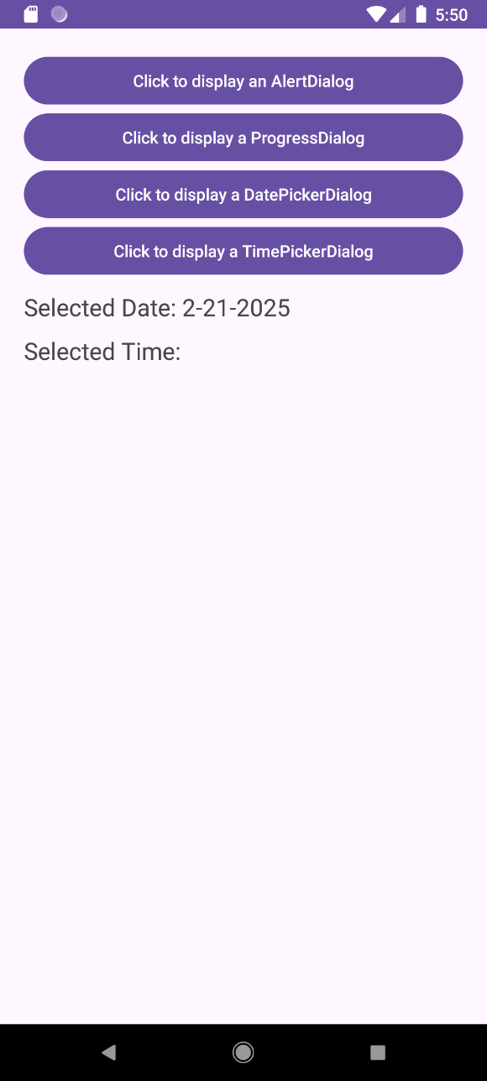

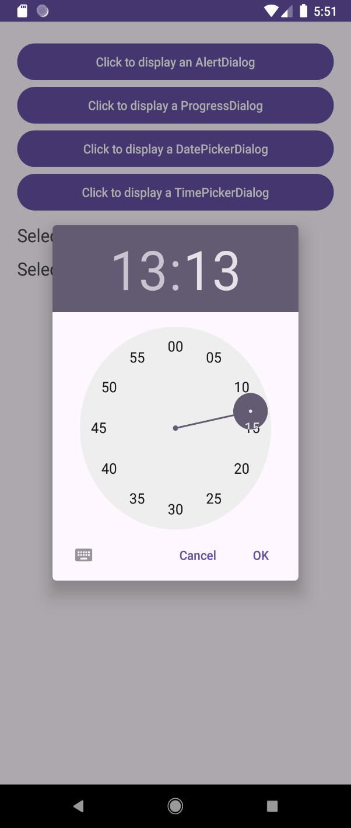 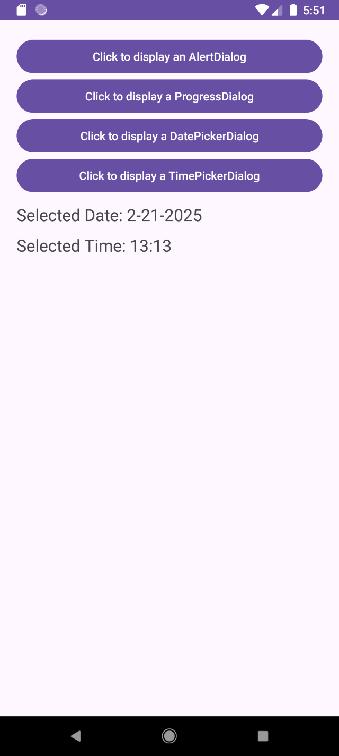

**Practical 5C**

**Aim:** Creating Dialogs Fragments

**DFragment.java**

package com.example.practical5c;  
import android.os.Bundle;  
import android.view.LayoutInflater;  
import android.view.View;  
import android.view.ViewGroup;  
import androidx.annotation.NonNull;  
import androidx.annotation.Nullable;  
import androidx.fragment.app.DialogFragment;  
public class DFragment extends DialogFragment {  
 @Nullable  
 @Override  
 public View onCreateView(@NonNull LayoutInflater inflater, @Nullable ViewGroup container, @Nullable Bundle savedInstanceState) {  
 View rootView = inflater.inflate(R.layout.*dialog_fragment*, container, false);  
 getDialog().setTitle("DialogFragment Test");  
 return rootView;  
 }  
}

**dialog_fragment.xml**

<?xml version="1.0" encoding="utf-8"?>  
<RelativeLayout  
 xmlns:android="http://schemas.android.com/apk/res/android"  
 android:layout_width="match_parent"  
 android:layout_height="match_parent"  
 android:padding="20dp">  
 <TextView  
 android:layout_width="wrap_content"  
 android:layout_height="wrap_content"  
 android:layout_centerInParent="true"  
 android:text="This is a DialogFragment"  
 android:textSize="18sp"/>  
</RelativeLayout>

**AlertDFragment.java**

package com.example.practical5c;  
import android.app.AlertDialog;  
import android.app.Dialog;  
import android.content.DialogInterface;  
import android.os.Bundle;  
import android.widget.Toast;  
import androidx.annotation.NonNull;  
import androidx.fragment.app.DialogFragment;  
public class AlertDFragment extends DialogFragment {  
 @NonNull  
 @Override  
 public Dialog onCreateDialog(Bundle savedInstanceState) {  
 return new AlertDialog.Builder(getActivity())  
 .setIcon(android.R.mipmap.*sym_def_app_icon*) // Set Dialog Icon  
 .setTitle("Alert Dialog Fragment") // Set Dialog Title  
 .setMessage("This is an AlertDialogFragment.") // Set Dialog Message  
 .setPositiveButton("OK", (dialog, which) ->  
 Toast.*makeText*(getContext(), "Ok Clicked", Toast.*LENGTH_LONG*).show())  
 .setNegativeButton("Cancel", (dialog, which) ->  
 Toast.*makeText*(getContext(), "Cancel Clicked", Toast.*LENGTH_LONG*).show())  
 .create();  
 }  
}

**activity_main.xml**

<?xml version="1.0" encoding="utf-8"?>  
<RelativeLayout  
 xmlns:android="http://schemas.android.com/apk/res/android"  
 xmlns:tools="http://schemas.android.com/tools"  
 android:layout_width="match_parent"  
 android:layout_height="match_parent"  
 tools:context=".MainActivity">  
 <Button  
 android:id="@+id/button_dialog_fragment"  
 android:layout_width="match_parent"  
 android:layout_height="wrap_content"  
 android:text="Show Dialog Fragment"  
 android:onClick="DialogFragment"/>  
 <Button  
 android:id="@+id/button_alert_fragment"  
 android:layout_width="match_parent"  
 android:layout_height="wrap_content"  
 android:text="Show Alert Dialog Fragment"  
 android:layout_below="@id/button_dialog_fragment"  
 android:layout_marginTop="10dp"  
 android:onClick="AlertFragment"/>  
</RelativeLayout>

**MainActivity.java**

package com.example.practical5c;  
import android.os.Bundle;  
import android.view.View;  
import androidx.appcompat.app.AppCompatActivity;  
import androidx.fragment.app.FragmentManager  
public class MainActivity extends AppCompatActivity {  
 FragmentManager fm;  
 @Override  
 protected void onCreate(Bundle savedInstanceState) {  
 super.onCreate(savedInstanceState);  
 setContentView(R.layout.*activity_main*);  
 fm = getSupportFragmentManager();  
 }  
 public void DialogFragment(View view) {  
 DFragment dFragment = new DFragment();  
 dFragment.show(fm, "Dialog Fragment");  
 }  
 public void AlertFragment(View view) {  
 AlertDFragment alertDFragment = new AlertDFragment();  
 alertDFragment.show(fm, "Alert Dialog Fragment");  
 }  
}

**Output:**

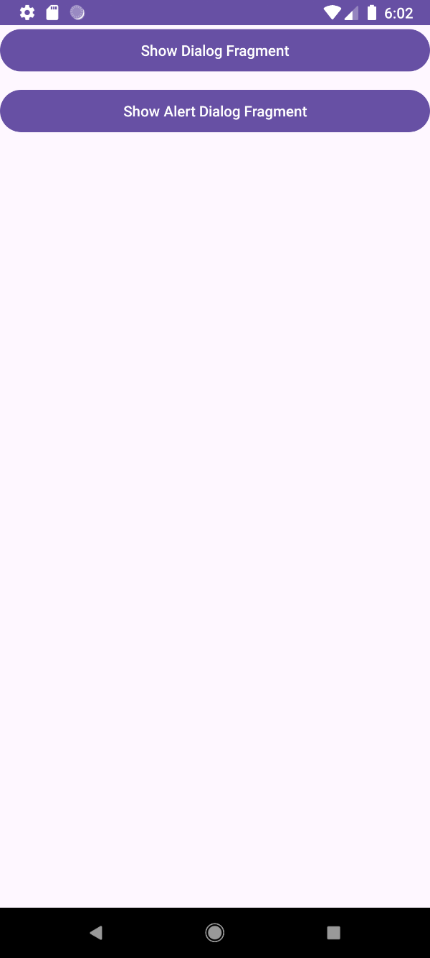 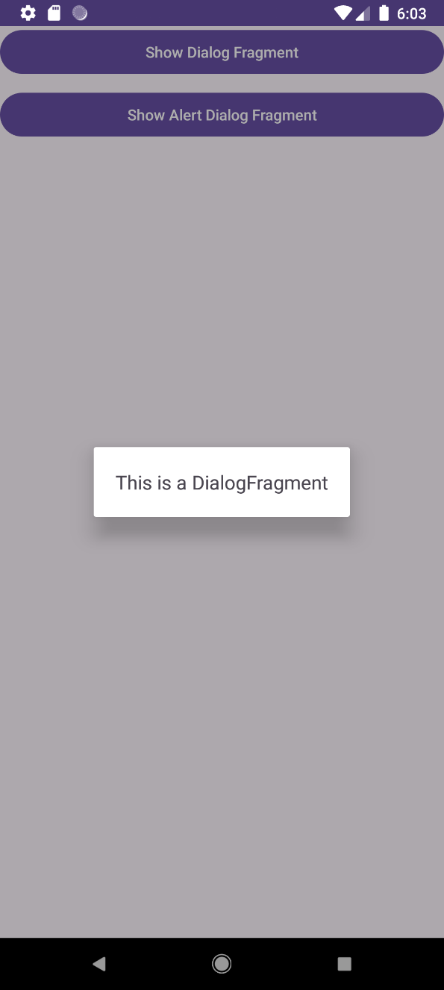

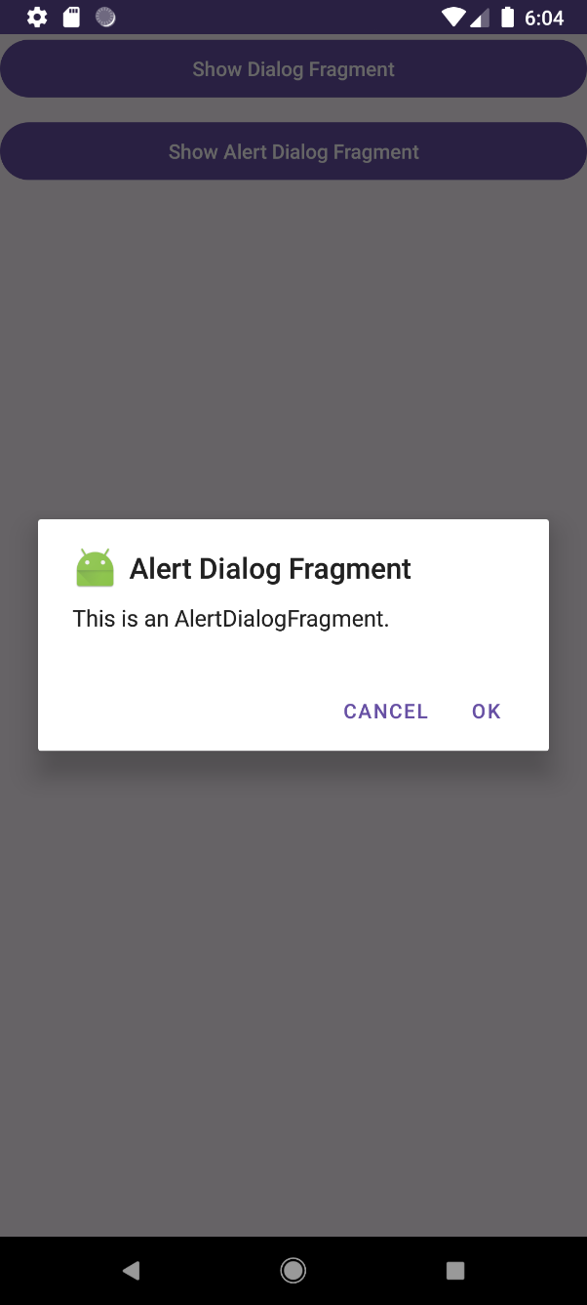 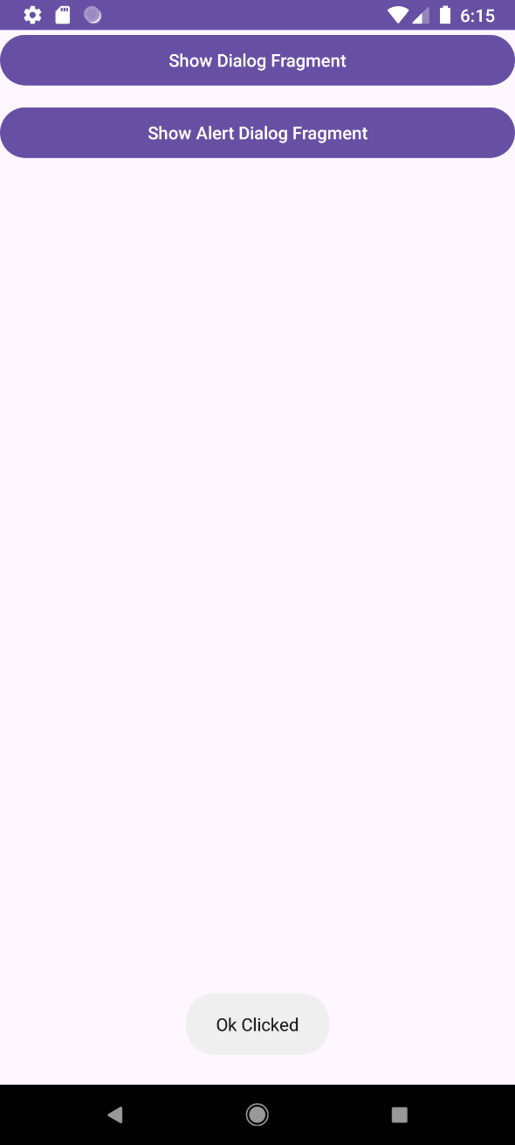

**Practical No 6**

**Aim :** The Android Intent Class

**activity_main.xml**

<?xml version="1.0" encoding="utf-8"?>

<LinearLayout

xmlns:android="http://schemas.android.com/apk/res/android"

xmlns:app="http://schemas.android.com/apk/res-auto"

xmlns:tools="http://schemas.android.com/tools"

android:layout_width="match_parent"

android:layout_height="match_parent"

android:orientation="vertical"

tools:context=".MainActivity"

android:padding="16dp">

<!-- EditText for user input -->

<EditText

android:id="@+id/editText_text"

android:layout_width="match_parent"

android:layout_height="wrap_content"

android:hint="Enter a value"

android:textSize="48dp"

android:inputType="text" />

<!-- Button to trigger action -->

<Button

android:id="@+id/button_click"

android:layout_width="wrap_content"

android:layout_height="wrap_content"

android:text="Click"

android:layout_gravity="center"

android:onClick="showntext" />

</LinearLayout>

**MainActivity.java**

package com.example.prac6;

import android.content.Intent;

import android.os.Bundle;

import android.view.View;

import android.widget.EditText;

import androidx.appcompat.app.AppCompatActivity;

public class MainActivity extends AppCompatActivity {

@Override

protected void onCreate(Bundle savedInstanceState) {

super.onCreate(savedInstanceState);

setContentView(R.layout.activity_main);

}

// This method is triggered when the button is clicked

public void showntext(View view) {

// Get the EditText view

EditText ed = findViewById(R.id.editText_text);

// Get the text entered in the EditText

String msg = ed.getText().toString();

// Create an Intent to start the newpage activity

Intent in = new Intent(this, newpage.class);

// Pass the value to the new activity

in.putExtra("my key", msg);

// Start the new activity

startActivity(in);

}

}

**activity_newpage.xml**

<?xml version="1.0" encoding="utf-8"?>

<RelativeLayout xmlns:android="http://schemas.android.com/apk/res/android"

xmlns:app="http://schemas.android.com/apk/res-auto"

xmlns:tools="http://schemas.android.com/tools"

android:id="@+id/main"

android:layout_width="match_parent"

android:layout_height="match_parent"

tools:context=".newpage">

<!-- TextView to display some text -->

<TextView

android:id="@+id/textView_view"

android:layout_width="wrap_content"

android:layout_height="wrap_content"

android:text="New Text"

android:textSize="20sp"

android:layout_centerInParent="true" />

</RelativeLayout>

**newpage.java**

package com.example.prac6;

import android.os.Bundle;

import android.widget.TextView;

import androidx.appcompat.app.AppCompatActivity;

public class newpage extends AppCompatActivity {

@Override

protected void onCreate(Bundle savedInstanceState) {

super.onCreate(savedInstanceState);

setContentView(R.layout.activity_newpage);

// Find the TextView

TextView tv1 = findViewById(R.id.textView_view);

// Get the value passed through the intent

String myvalue = getIntent().getStringExtra("my key");

// Check if the value is null

if (myvalue != null) {

tv1.setText("Value = " + myvalue);

} else {

tv1.setText("No value passed");

}

}

}

**Output:**

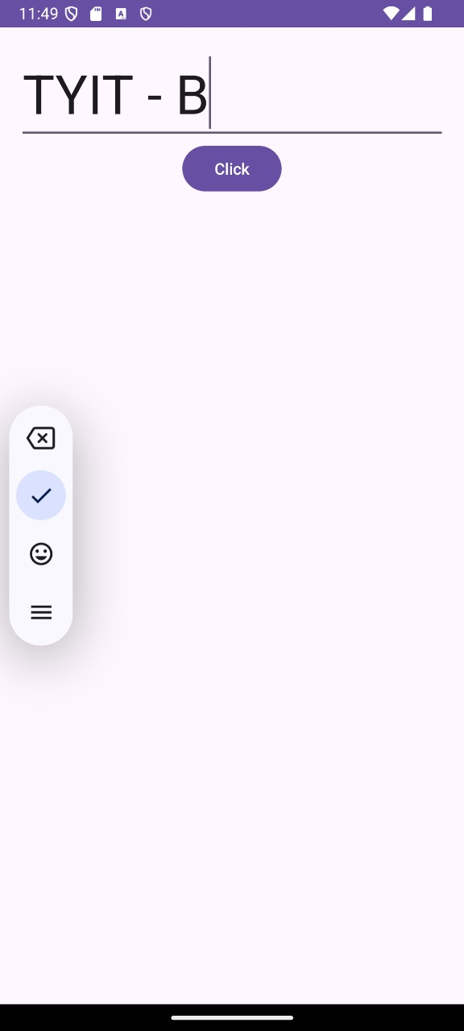 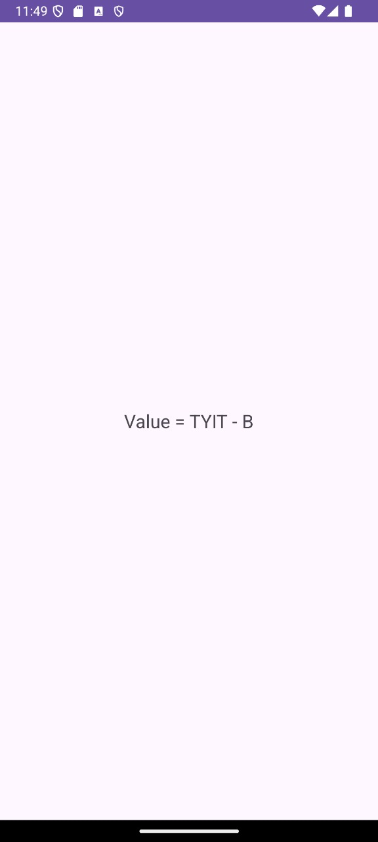

**Practical No 7**

**Practical 7A**

**Aim :** Program on Services

**activity_main.xml**

<?xml version="1.0" encoding="utf-8"?>  
<androidx.constraintlayout.widget.ConstraintLayout xmlns:android="http://schemas.android.com/apk/res/android"  
 xmlns:app="http://schemas.android.com/apk/res-auto"  
 xmlns:tools="http://schemas.android.com/tools"  
 android:layout_width="match_parent"  
 android:layout_height="match_parent"  
 tools:context=".MainActivity">  
<Button  
 android:id="@+id/btnStart"  
 android:layout_width="wrap_content"  
 android:layout_height="wrap_content"  
 android:text="Start Service"  
 android:onClick="startService"  
 app:layout_constraintBottom_toBottomOf="parent"  
 app:layout_constraintEnd_toEndOf="parent"  
 app:layout_constraintStart_toStartOf="parent"  
 app:layout_constraintTop_toTopOf="parent"></Button>  
<Button  
android:id="@+id/btnStop"  
android:onClick="stopService"  
android:layout_width="wrap_content"  
android:layout_height="wrap_content"  
android:text="Stop Service"  
app:layout_constraintBottom_toBottomOf="parent"  
app:layout_constraintEnd_toEndOf="parent"  
app:layout_constraintStart_toStartOf="parent"  
app:layout_constraintTop_toBottomOf="@+id/btnStart">

</Button>  
</androidx.constraintlayout.widget.ConstraintLayout>

**MyServices.java**

package com.example.practical7a**;**import android.app.Service**;**import android.content.Intent**;**import android.os.IBinder**;**import android.widget.Toast**;**import androidx.annotation.Nullable**;**public class MyServices extends Service {  
 @Override  
 public void onCreate(){  
 super.onCreate()**;** }  
 @Override  
 public int onStartCommand(Intent intent**,** int flags **,** int startId){  
 Toast.*makeText*(this**,** "Services Started..."**,** Toast.*LENGTH_LONG*).show()**;** return *START_STICKY***;** }  
 public void onDestroy(){  
 Toast.*makeText*(this**,** "Services Destroyed..."**,** Toast.*LENGTH_LONG*).show()**;** }  
 @Nullable  
 @Override  
 public IBinder onBind (Intent intent){  
 return null**;** }  
}

**MainActivity.java**

package com.example.practical7a**;**import androidx.appcompat.app.AppCompatActivity**;**import android.os.Bundle**;**import android.content.Intent**;**import android.view.View**;**public class MainActivity extends AppCompatActivity {  
 @Override  
 protected void onCreate(Bundle savedInstanceState) {  
 super.onCreate(savedInstanceState)**;** setContentView(R.layout.*activity_main*)**;** }  
 public void startService(View view)  
 {  
 Intent intent=new Intent(this**,** MyServices.class)**;** startService(intent)**;** }  
 public void stopService(View view)  
 {  
 Intent intent=new Intent(this**,** MyServices.class)**;** stopService(intent)**;** }  
}

**Output:**

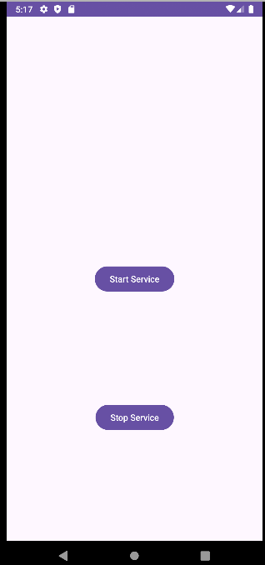 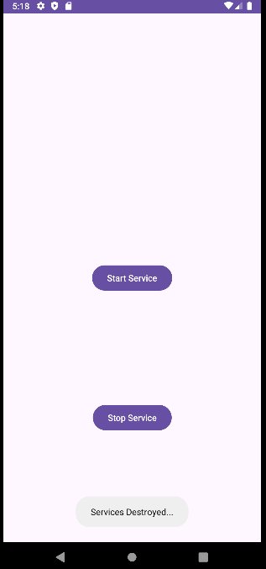

**Practical 7B**

**Aim :** Programs on notification

**activity_main.xml**

<?xml version="1.0" encoding="utf-8"?>  
<androidx.constraintlayout.widget.ConstraintLayout xmlns:android="http://schemas.android.com/apk/res/android"  
 xmlns:app="http://schemas.android.com/apk/res-auto"  
 xmlns:tools="http://schemas.android.com/tools"  
 android:layout_width="match_parent"  
 android:layout_height="match_parent"  
 tools:context=".MainActivity">  
 <TextView  
 android:layout_width="wrap_content"  
 android:layout_height="wrap_content"  
 android:text="Hello World!"  
 app:layout_constraintBottom_toBottomOf="parent"  
 app:layout_constraintEnd_toEndOf="parent"  
 app:layout_constraintStart_toStartOf="parent"  
 app:layout_constraintTop_toTopOf="parent" />  
</androidx.constraintlayout.widget.ConstraintLayout>

**AndroidManifest.xml**

<?xml version="1.0" encoding="utf-8"?>  
<manifest xmlns:android="http://schemas.android.com/apk/res/android"  
 xmlns:tools="http://schemas.android.com/tools">  
<uses-permission android:name="android.permission.POST_NOTIFICATIONS"/>  
 <application  
 android:allowBackup="true"  
 android:dataExtractionRules="@xml/data_extraction_rules"  
 android:fullBackupContent="@xml/backup_rules"  
 android:icon="@mipmap/ic_launcher"  
 android:label="@string/app_name"  
 android:roundIcon="@mipmap/ic_launcher_round"  
 android:supportsRtl="true"  
 android:theme="@style/Theme.Pract"  
 tools:targetApi="31">  
 <activity  
 android:name=".MainActivity"  
 android:exported="true">  
 <intent-filter>  
 <action android:name="android.intent.action.MAIN" />  
 <category android:name="android.intent.category.LAUNCHER" />  
 </intent-filter>  
 </activity>  
 </application>  
</manifest>

**MainActivity.java**

package com.example.pract;  
import androidx.appcompat.app.AppCompatActivity;  
import androidx.core.app.NotificationCompat;  
import androidx.core.app.NotificationManagerCompat;  
import android.app.NotificationChannel;  
import android.app.NotificationManager;  
import android.os.Build;  
import android.os.Bundle;  
import android.widget.Toast;  
import android.view.View;  
public class MainActivity extends AppCompatActivity {  
public final String CHANNEL_ID="personal_notification";  
public final int NOTIFICATION_ID=001;  
 @Override  
 protected void onCreate(Bundle savedInstanceState) {  
 super.onCreate(savedInstanceState);  
 setContentView(R.layout.*activity_main*);  
 }  
 public void displayNotification(View view)  
 {  
 createNotificationChannel();  
 Toast.*makeText*(getApplicationContext(), "Hi", Toast.*LENGTH_LONG*).show();  
 NotificationCompat.Builder builder=new NotificationCompat.Builder(this,CHANNEL_ID);  
 builder.setSmallIcon(R.mipmap.*ic_launcher*);  
 builder.setContentTitle("Simple Notification");  
 builder.setContentText("THis is a test Notification");  
 builder.setPriority(NotificationCompat.*PRIORITY_DEFAULT*);  
 NotificationManagerCompat notificationManagerCompat=NotificationManagerCompat.*from*(this);  
 notificationManagerCompat.notify(NOTIFICATION_ID,builder.build());  
 }  
 private void createNotificationChannel()  
 {  
 if(Build.VERSION.*SDK_INT*>=Build.VERSION_CODES.*O*)  
 {  
 CharSequence name="Personal Notification";  
 String description="This is description";  
 int importance= NotificationManager.*IMPORTANCE_DEFAULT*;  
 NotificationChannel notificationChannel=new NotificationChannel(CHANNEL_ID,name,importance);  
 notificationChannel.setDescription(description);  
 NotificationManager notificationManager=(NotificationManager)getSystemService(*NOTIFICATION_SERVICE*);  
 notificationManager.createNotificationChannel(notificationChannel);  
 }  
 }  
}

**Output:**

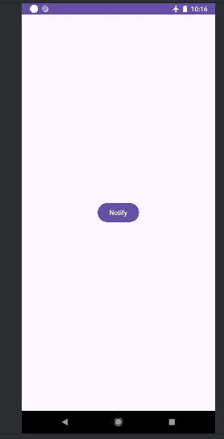 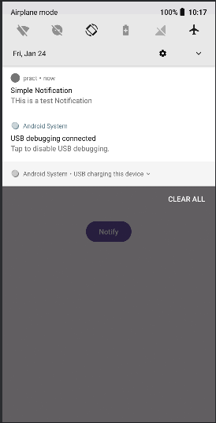

**Practical 7C**

**Aim :** Programs on broadcast receivers

**MainActivity.java**

package com.example.broadcastb;  
import androidx.appcompat.app.AppCompatActivity;  
import android.content.Intent;  
import android.content.IntentFilter;  
import android.os.Bundle;  
public class MainActivity extends AppCompatActivity {  
AirplaneModeChangeReceiver airplaneModeChangeReceiver=new AirplaneModeChangeReceiver();  
 @Override  
 protected void onCreate(Bundle savedInstanceState) {  
 super.onCreate(savedInstanceState);  
 setContentView(R.layout.*activity_main*);  
 }  
 @Override  
 protected void onStart()  
 {  
 super.onStart();  
 IntentFilter filter=new IntentFilter(Intent.*ACTION_AIRPLANE_MODE_CHANGED*);  
 registerReceiver(airplaneModeChangeReceiver,filter);  
 }  
 @Override  
 protected void onStop()  
 {  
 super.onStop();  
 unregisterReceiver(airplaneModeChangeReceiver);  
 }  
}

**Java Class –AirplaneModeChangeReceiver.java**

package com.example.broadcastb;  
import android.content.BroadcastReceiver;  
import android.content.Context;  
import android.content.Intent;  
import android.provider.Settings;  
import android.widget.Toast;  
public class AirplaneModeChangeReceiver extends BroadcastReceiver {  
 @Override  
 public void onReceive(Context context, Intent intent)  
 {  
 if(*isAirplaneModeOn*(context.getApplicationContext()))  
 {  
 Toast.*makeText*(context, "AirPlane mode is on", Toast.*LENGTH_LONG*).show();  
 }  
 else {  
 Toast.*makeText*(context, "AirPlane mode is off", Toast.*LENGTH_LONG*).show();  
 }  
 }  
 private static boolean isAirplaneModeOn(Context context)  
 {  
 return Settings.System.*getInt*(context.getContentResolver(),  
 Settings.Global.*AIRPLANE_MODE_ON*,0) !=0;  
 }  
}

**Output:**

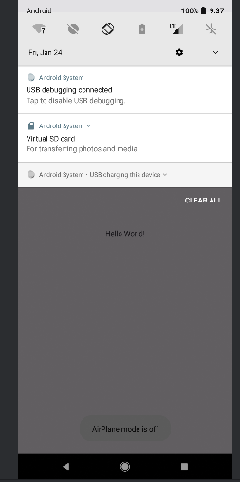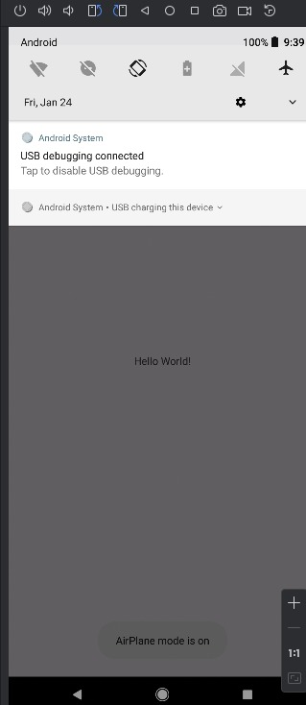

**Practical 8**

**Practical 8A**

**Aim :** Database Programming with SQLite

**activity_main.xml**

<?xml version="1.0" encoding="utf-8"?>  
<LinearLayout  
 xmlns:android="http://schemas.android.com/apk/res/android"  
 android:layout_width="match_parent"  
 android:layout_height="match_parent"  
 android:orientation="vertical"  
 android:padding="16dp">  
 <LinearLayout  
 android:layout_width="match_parent"  
 android:layout_height="wrap_content"  
 android:orientation="horizontal"  
 android:gravity="center_vertical"  
 android:paddingBottom="8dp">  
 <TextView  
 android:id="@+id/user"  
 android:layout_width="wrap_content"  
 android:layout_height="wrap_content"  
 android:text="Username:" />  
 <EditText  
 android:id="@+id/etun"  
 android:layout_width="0dp"  
 android:layout_height="wrap_content"  
 android:layout_weight="1"  
 android:hint="Enter username"  
 android:inputType="textPersonName"  
 android:layout_marginStart="8dp" />  
 </LinearLayout>  
 <LinearLayout  
 android:layout_width="match_parent"  
 android:layout_height="wrap_content"  
 android:orientation="horizontal"  
 android:gravity="center_vertical"  
 android:paddingBottom="16dp">  
 <TextView  
 android:id="@+id/ipass"  
 android:layout_width="wrap_content"  
 android:layout_height="wrap_content"  
 android:text="Password:" />  
 <EditText  
 android:id="@+id/etp"  
 android:layout_width="0dp"  
 android:layout_height="wrap_content"  
 android:layout_weight="1"  
 android:hint="Enter password"  
 android:inputType="textPassword"  
 android:layout_marginStart="8dp" />  
 </LinearLayout>  
 <Button  
 android:id="@+id/reg"  
 android:layout_width="match_parent"  
 android:layout_height="wrap_content"  
 android:text="Register" />  
 <Button  
 android:id="@+id/lg"  
 android:layout_width="match_parent"  
 android:layout_height="wrap_content"  
 android:layout_marginTop="16dp"  
 android:text="Login" />  
 <Button  
 android:id="@+id/dr"  
 android:layout_width="match_parent"  
 android:layout_height="wrap_content"  
 android:layout_marginTop="16dp"  
 android:text="Drop" />  
</LinearLayout>

**MainActivity.java**

package com.example.prac_8a;  
import androidx.appcompat.app.AppCompatActivity;  
import android.content.Context;  
import android.database.Cursor;  
import android.database.sqlite.SQLiteDatabase;  
import android.database.sqlite.SQLiteException;  
import android.database.sqlite.SQLiteOpenHelper;  
import android.os.Bundle;  
import android.view.View;  
import android.widget.Button;  
import android.widget.EditText;  
import android.widget.Toast;  
class MyDB extends SQLiteOpenHelper {  
 MyDB(Context c) {  
 super(c, "logindb", null, 1);  
 } @Override  
 public void onCreate(SQLiteDatabase db) {  
 String str = "CREATE TABLE login(username TEXT, password TEXT)";  
 db.execSQL(str);  
 }  
 @Override  
 public void onUpgrade(SQLiteDatabase db, int oldVersion, int newVersion) {  
 String dr = "DROP TABLE IF EXISTS login";  
 db.execSQL(dr);  
 onCreate(db);  
 }}  
public class MainActivity extends AppCompatActivity {  
 MyDB mdb;  
 EditText u, p;  
 Button breg, bdr, blg;  
 SQLiteDatabase db;  
 @Override  
 protected void onCreate(Bundle savedInstanceState) {  
 super.onCreate(savedInstanceState);  
 setContentView(R.layout.*activity_main*);  
 u = findViewById(R.id.*etun*);  
 p = findViewById(R.id.*etp*);  
 blg = findViewById(R.id.*lg*);  
 breg = findViewById(R.id.*reg*);  
 bdr = findViewById(R.id.*dr*);  
 mdb = new MyDB(this);  
 // Set click listeners for buttons  
 blg.setOnClickListener(this::login_fun);  
 breg.setOnClickListener(this::reg_fun);  
 bdr.setOnClickListener(this::dr_fun);  
 }  
 public void login_fun(View v) {  
 String un = u.getText().toString();  
 String pas = p.getText().toString();  
 db = mdb.getReadableDatabase();  
 String q = "SELECT * FROM login WHERE username=? AND password=?";  
 try (Cursor c = db.rawQuery(q, new String[]{un, pas})) {  
 if (c.getCount() == 0) {  
 Toast.*makeText*(getApplicationContext(), "Username or password wrong or user doesn't exist", Toast.*LENGTH_SHORT*).show();  
 } else {  
 while (c.moveToNext()) {  
 String uname = c.getString(0);  
 String passw = c.getString(1);  
 Toast.*makeText*(getApplicationContext(), "Username: " + uname + "\nPassword: " + passw, Toast.*LENGTH_LONG*).show();  
 if (un.equals(uname) && pas.equals(passw)) {  
 Toast.*makeText*(getApplicationContext(), "Welcome user: " + un, Toast.*LENGTH_LONG*).show();  
 } } }  
 } catch (SQLiteException sqle) {  
 sqle.printStackTrace();  
 }  
 }  
 public void reg_fun(View v) {  
 String un = u.getText().toString();  
 String pas = p.getText().toString();  
 db = mdb.getWritableDatabase();  
 String q = "INSERT INTO login VALUES(?, ?)";  
 db.execSQL(q, new Object[]{un, pas});  
 Toast.*makeText*(getApplicationContext(), "User registered", Toast.*LENGTH_LONG*).show();  
 }

public void dr_fun(View v) {

u.setText("");

p.setText("");

db = mdb.getWritableDatabase();

mdb.onUpgrade(db, 1, 2);

Toast.*makeText*(getApplicationContext(), "All Users Deleted", Toast.*LENGTH_SHORT*).show();

}}  
**Output:**

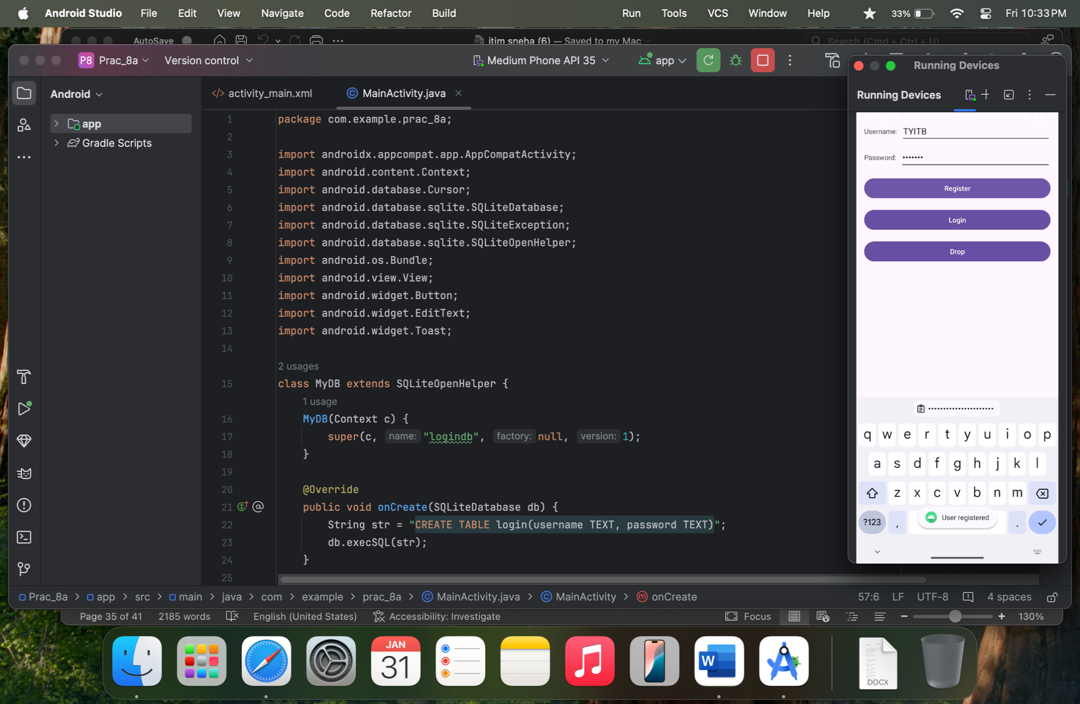 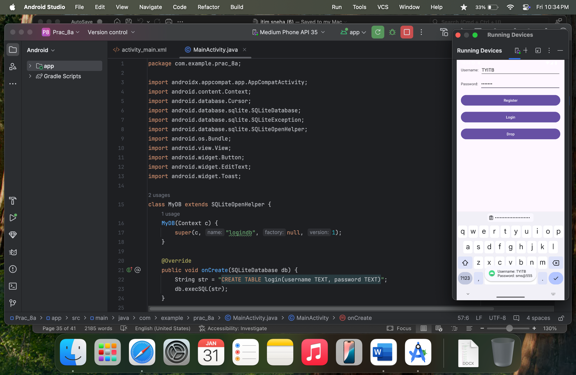 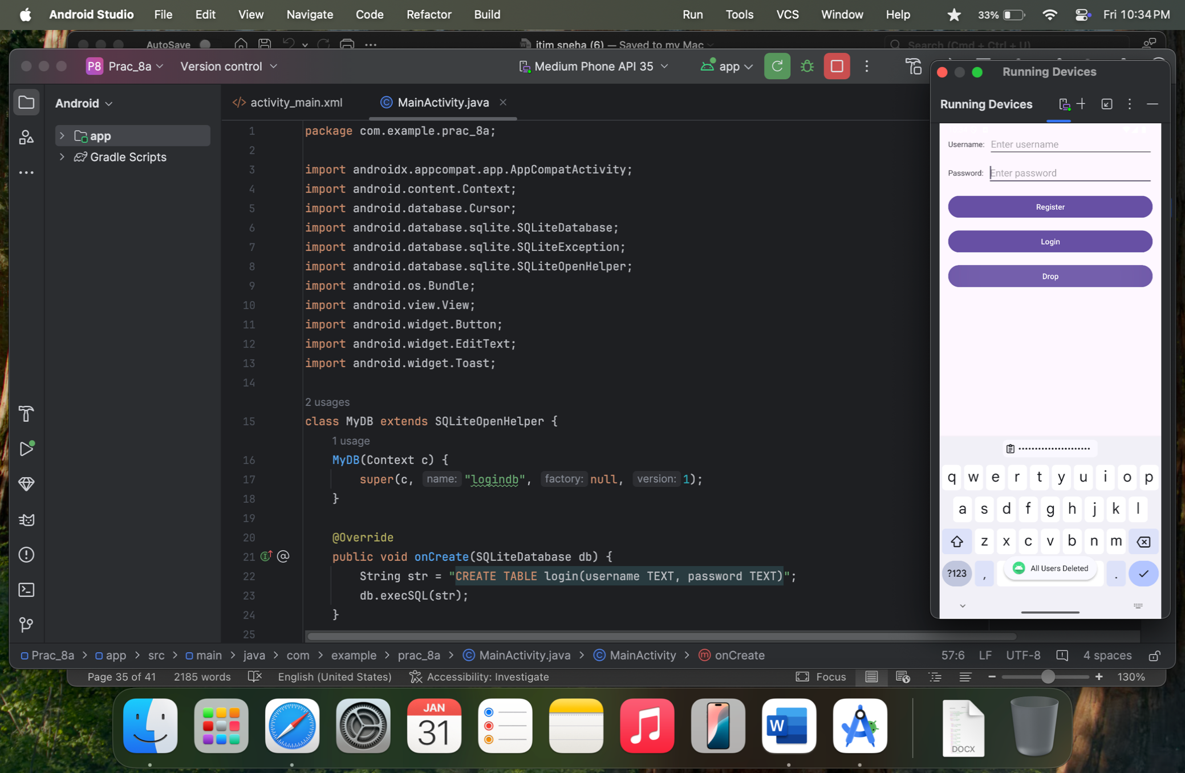

**Practical 8B**

**Aim :** Programming Network Communications and Services (JSON)

**activity_main.xml**

<?xml version="1.0" encoding="utf-8"?>  
<LinearLayout xmlns:android="http://schemas.android.com/apk/res/android"  
 xmlns:app="http://schemas.android.com/apk/res-auto"  
 xmlns:tools="http://schemas.android.com/tools"  
 android:layout_width="match_parent"  
 android:layout_height="match_parent"  
 android:orientation="vertical"  
 tools:context=".MainActivity">  
 <Button  
 android:id="@+id/button_fetch"  
 android:layout_width="wrap_content"  
 android:layout_height="wrap_content"  
 android:text="Fetch JSON"/>  
 <TextView  
 android:id="@+id/textView_result"  
 android:layout_width="match_parent"  
 android:layout_height="wrap_content"  
 android:layout_marginTop="16dp"  
 android:text="JSON data will appear here"/>  
</LinearLayout>

**MainActivity.java**

package com.example.json;  
import androidx.appcompat.app.AppCompatActivity;  
import android.os.Bundle;  
import android.view.View;  
import android.widget.Button;  
import android.widget.TextView;  
import com.android.volley.Request;  
import com.android.volley.RequestQueue;  
import com.android.volley.toolbox.Volley;  
import com.android.volley.toolbox.JsonObjectRequest;  
import com.android.volley.Response;  
import com.android.volley.VolleyError;  
import org.json.JSONObject;  
public class MainActivity extends AppCompatActivity {  
 TextView textViewResult; // Declare TextView here for consistency  
 @Override  
 protected void onCreate(Bundle savedInstanceState) {  
 super.onCreate(savedInstanceState);  
 setContentView(R.layout.*activity_main*);  
 Button buttonFetch = findViewById(R.id.*button_fetch*);  
 textViewResult = findViewById(R.id.*textView_result*); // Assign the TextView correctly  
 buttonFetch.setOnClickListener(new View.OnClickListener() {  
 @Override  
 public void onClick(View v) {  
 fetchJSON();  
 }  
 });  
 }  
 private void fetchJSON() {  
 String url ="https://jsonplaceholder.typicode.com/todos/1";  
 RequestQueue queue = Volley.*newRequestQueue*(this);  
 JsonObjectRequest jsonObjectRequest = new JsonObjectRequest(  
 Request.Method.*GET*, url, null,  
 new Response.Listener<JSONObject>() {  
 @Override  
 public void onResponse(JSONObject response) {  
 try {  
 // Extracting all fields from the JSON response  
 String userId = response.getString("userId");  
 String id = response.getString("id");  
 String title = response.getString("title");  
 String completed = response.getString("completed");  
 // Displaying all the fields in the TextView  
 textViewResult.setText("User ID: " + userId + "\nID: " + id + "\nTitle: " + title + "\nCompleted: " + completed);  
 } catch (Exception e) {  
 textViewResult.setText("Error: " + e.getMessage());  
 }  
 }  
 },  
 new Response.ErrorListener() {  
 @Override  
 public void onErrorResponse(VolleyError error) {  
 textViewResult.setText("Error: " + error.getMessage());  
 }  
 }  
 );  
 queue.add(jsonObjectRequest);  
 }  
}

**buid.gradle(module:app)**

dependencies **{**implementation"com.android.volley:volley:1.2.1"}

**AndroidManifest.xml**

<uses-permission android:name="android.permission.INTERNET"/>

**Output:**

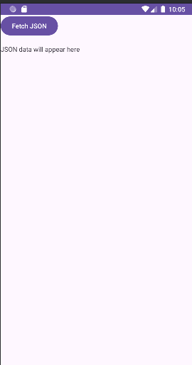 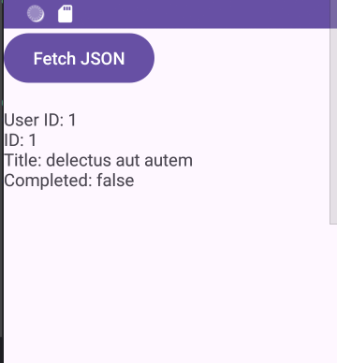

**Practical 9**

**Practical 9A**

**Aim :** Threads

**activity_main.xml**

<?xml version="1.0" encoding="utf-8"?>  
<LinearLayout xmlns:android="http://schemas.android.com/apk/res/android"  
 xmlns:app="http://schemas.android.com/apk/res-auto"  
 xmlns:tools="http://schemas.android.com/tools"  
 android:layout_width="match_parent"  
 android:layout_height="match_parent"  
 android:orientation="vertical"  
 tools:context=".MainActivity">  
 <ProgressBar  
 android:id="@+id/progressBar1"  
 style="?android:attr/progressBarStyleHorizontal"  
 android:layout_width="match_parent"  
 android:layout_height="wrap_content"  
 android:indeterminate="false"  
 android:max="10"  
 android:padding="4dip"/>  
 <Button  
 android:layout_width="wrap_content"  
 android:layout_height="wrap_content"  
 android:text="Button"  
 android:onClick="startProgress"/>  
</LinearLayout>

**MainActivity.java**

package com.example.practical8a;  
import androidx.appcompat.app.AppCompatActivity;  
import android.os.Bundle;  
import android.view.View;  
import android.widget.ProgressBar;  
public class MainActivity extends AppCompatActivity {  
 private ProgressBar bar;  
 @Override  
 protected void onCreate(Bundle savedInstanceState) {  
 super.onCreate(savedInstanceState);  
 setContentView(R.layout.*activity_main*);  
 bar=(ProgressBar) findViewById(R.id.*progressBar1*);  
 }  
 public void startProgress(View view){  
 bar.setProgress(0);  
 new Thread(new Task()).start();  
 }  
 class Task implements Runnable{  
 public void run(){  
 for(int i=0;i<=10;i++)  
 {  
 final int value=i;  
 try{  
 Thread.*sleep*(1000);  
 }catch (InterruptedException e){  
 e.printStackTrace();  
 }  
 bar.setProgress(value);  
 }  
 }  
 }  
}

**Output:**

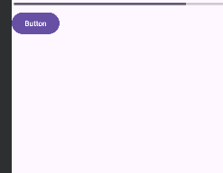

**Practical 9B**

**Aim :** Handler

**activity_main.xml**

package com.example.practical9b;  
import android.os.Bundle;  
import android.os.Handler;  
import android.view.View;  
import android.widget.TextView;  
import androidx.activity.EdgeToEdge;  
import androidx.appcompat.app.AppCompatActivity;  
import androidx.core.graphics.Insets;  
import androidx.core.view.ViewCompat;  
import androidx.core.view.WindowInsetsCompat;  
public class MainActivity extends AppCompatActivity {  
 TextView textView;  
 private int stopLoop=30;  
 @Override  
 protected void onCreate(Bundle savedInstanceState) {  
 super.onCreate(savedInstanceState);  
 EdgeToEdge.*enable*(this);  
 setContentView(R.layout.*activity_main*);  
 ViewCompat.*setOnApplyWindowInsetsListener*(findViewById(R.id.*main*), (v, insets) -> {  
 Insets systemBars = insets.getInsets(WindowInsetsCompat.Type.*systemBars*());  
 v.setPadding(systemBars.left, systemBars.top, systemBars.right, systemBars.bottom);  
 return insets;  
 });  
 textView=(TextView) findViewById(R.id.*textView*);  
 }  
 public void timer(View view){  
 final Handler handler=new Handler();  
 handler.post(new Runnable(){  
 public void run(){  
 if(stopLoop>0){  
 stopLoop--;  
 textView.setText("Time:"+stopLoop);  
 handler.postDelayed(this,1000);  
 }  
 else{  
 }  
 }  
 });  
 }  
 public void nonTimer(View view){  
 int i=0;  
 for(i=0;i<3;i++){  
 textView.setText("Time:"+i);  
 try{  
 Thread.*sleep*(1000);  
 }catch(InterruptedException e){  
 e.printStackTrace();  
 }  
 }  
 }  
}

**MainActivity.java**

package com.example.practical9b;  
import android.os.Bundle;  
import android.os.Handler;  
import android.view.View;  
import android.widget.TextView;  
import androidx.activity.EdgeToEdge;  
import androidx.appcompat.app.AppCompatActivity;  
import androidx.core.graphics.Insets;  
import androidx.core.view.ViewCompat;  
import androidx.core.view.WindowInsetsCompat;  
public class MainActivity extends AppCompatActivity {  
 TextView textView;  
 private int stopLoop=30;  
 @Override  
 protected void onCreate(Bundle savedInstanceState) {  
 super.onCreate(savedInstanceState);  
 EdgeToEdge.*enable*(this);  
 setContentView(R.layout.*activity_main*);  
 ViewCompat.*setOnApplyWindowInsetsListener*(findViewById(R.id.*main*), (v, insets) -> {  
 Insets systemBars = insets.getInsets(WindowInsetsCompat.Type.*systemBars*());  
 v.setPadding(systemBars.left, systemBars.top, systemBars.right, systemBars.bottom);  
 return insets;  
 });  
 textView=(TextView) findViewById(R.id.*textView*);  
 }  
 public void timer(View view){  
 final Handler handler=new Handler();  
 handler.post(new Runnable(){  
 public void run(){  
 if(stopLoop>0){  
 stopLoop--;  
 textView.setText("Time:"+stopLoop);  
 handler.postDelayed(this,1000);  
 }  
 else{  
 }  
 }  
 });  
 }  
 public void nonTimer(View view){  
 int i=0;  
 for(i=0;i<3;i++){  
 textView.setText("Time:"+i);  
 try{  
 Thread.*sleep*(1000);  
 }catch(InterruptedException e){  
 e.printStackTrace();  
 }  
 }  
 }  
}

**Output:**

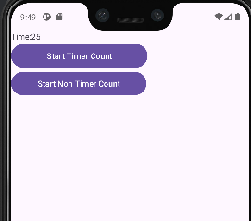 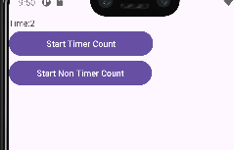

**Practical 9C**

**Aim :** Programming AsyncTask

**activity_main.xml**

<?xml version="1.0" encoding="utf-8"?>  
<androidx.constraintlayout.widget.ConstraintLayout xmlns:android="http://schemas.android.com/apk/res/android" xmlns:app="http://schemas.android.com/apk/res-auto"

xmlns:tools="http://schemas.android.com/tools"

android:id="@+id/main"

android:layout_width="match_parent"

android:layout_height="match_parent"

tools:context=".MainActivity">

<TextView

android:id="@+id/textView"

android:layout_width="wrap_content"

android:layout_height="wrap_content"

android:text="Hello World!"

app:layout_constraintBottom_toBottomOf="parent"

app:layout_constraintEnd_toEndOf="parent"

app:layout_constraintLeft_toLeftOf="parent"

app:layout_constraintRight_toRightOf="parent"

app:layout_constraintStart_toStartOf="parent"

app:layout_constraintTop_toTopOf="parent"

app:layout_constraintVertical_bias="0.168"/>

<Button

android:layout_width="wrap_content"

android:layout_height="wrap_content"

android:id="@+id/button"

android:layout_marginTop="112dp"

android:text="Button"

app:layout_constraintEnd_toEndOf="parent"

app:layout_constraintStart_toStartOf="parent"

app:layout_constraintTop_toTopOf="parent"/>

</androidx.constraintlayout.widget.ConstraintLayout>

**MainActivity.java**

package com.example.prac_9c;

import android.os.Bundle;

import android.view.View;

import android.widget.Button;

import android.widget.TextView;

import androidx.appcompat.app.AppCompatActivity;

public class MainActivity extends AppCompatActivity {

TextView textView;

Button button;

@Override

protected void onCreate(Bundle savedInstanceState) {

super.onCreate(savedInstanceState);

setContentView(R.layout.activity_main);

textView = findViewById(R.id.textView);

button = findViewById(R.id.button);

button.setOnClickListener(new View.OnClickListener() {

@Override

public void onClick(View v) {

MyTask myTask = new MyTask(MainActivity.this, textView, button);

myTask.execute();

button.setEnabled(false);

}

});

}

}

**MyTask.java**  
package com.example.prac_9c;

import android.app.ProgressDialog;

import android.content.Context;

import android.os.AsyncTask;

import android.widget.Button;

import android.widget.TextView;

public class MyTask extends AsyncTask<Void, Integer, String> {

Context context;

Button button;

TextView textView;

ProgressDialog progressDialog;

MyTask(Context context, TextView textView, Button button) {

this.context = context;

this.textView = textView;

this.button = button;

}

@Override

protected void onPreExecute() {

super.onPreExecute();

progressDialog = new ProgressDialog(context);

progressDialog.setTitle("Download in Progress");

progressDialog.setMax(10);

progressDialog.setProgress(0);

progressDialog.setProgressStyle(ProgressDialog.STYLE_HORIZONTAL);

progressDialog.show();

}

@Override

protected void onPostExecute(String s) {

super.onPostExecute(s);

progressDialog.dismiss(); // Dismiss progress dialog after completion

textView.setText("Download Finish");

button.setEnabled(true);

}

@Override

protected void onProgressUpdate(Integer... values) {

super.onProgressUpdate(values);

int progress = values[0];

progressDialog.setProgress(progress);

textView.setText("Download In Progress (" + progress + "/10)");

}

@Override

protected String doInBackground(Void... voids) {

for (int i = 1; i <= 10; i++) {

try {

Thread.sleep(1000); // Corrected the issue (previously used wait())

publishProgress(i);

} catch (InterruptedException e) {

e.printStackTrace();

return "Download Interrupted"; // Handle interruption properly

}

}

return "Download Finish";

    }

}

**Output:**

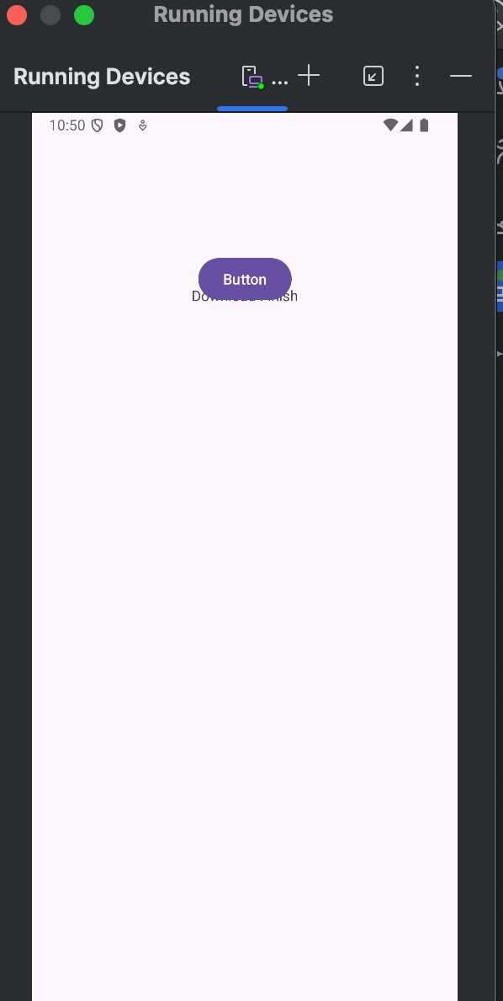 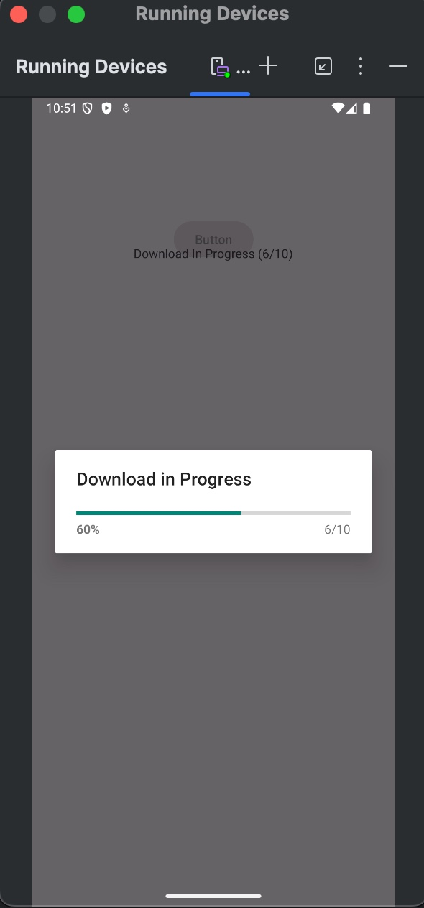

**Practical 10**

**Practical 10A**

**Aim :** Programming Media API

**activity_main.xml**

<?xml version="1.0" encoding="utf-8"?>  
<RelativeLayout xmlns:android="http://schemas.android.com/apk/res/android"  
 xmlns:app="http://schemas.android.com/apk/res-auto"  
 xmlns:tools="http://schemas.android.com/tools"  
 android:id="@+id/main"  
 android:layout_width="match_parent"  
 android:layout_height="match_parent"  
 tools:context=".MainActivity">  
 <!-- Button with id for reference -->  
 <Button  
 android:id="@+id/button"  
 android:layout_width="wrap_content"  
 android:layout_height="wrap_content"  
 android:text="Start"  
 android:layout_centerInParent="true"/>  
</RelativeLayout>

**MainActivity.java**

package com.example.practical10a;  
import android.os.Bundle;  
import android.media.MediaPlayer;  
import android.view.View;  
import android.widget.Button;  
import android.widget.Toast;  
import androidx.activity.EdgeToEdge;  
import androidx.appcompat.app.AppCompatActivity;  
import androidx.core.graphics.Insets;  
import androidx.core.view.ViewCompat;  
import androidx.core.view.WindowInsetsCompat;  
public class MainActivity extends AppCompatActivity {  
 private Button bn;  
 private MediaPlayer mediaPlayer;  
 @Override  
 protected void onCreate(Bundle savedInstanceState) {  
 super.onCreate(savedInstanceState);  
 EdgeToEdge.*enable*(this);  
 setContentView(R.layout.*activity_main*);  
 // Apply window insets for edge-to-edge display  
 ViewCompat.*setOnApplyWindowInsetsListener*(findViewById(R.id.*main*), (v, insets) -> {  
 Insets systemBars = insets.getInsets(WindowInsetsCompat.Type.*systemBars*());  
 v.setPadding(systemBars.left, systemBars.top, systemBars.right, systemBars.bottom);  
 return insets;  
 }); // Initialize the button  
 bn = findViewById(R.id.*button*);  
 bn.setOnClickListener(new View.OnClickListener() {  
 @Override  
 public void onClick(View v) {  
 mediaPlayer = MediaPlayer.*create*(getApplicationContext(), R.raw.*song*);  
 mediaPlayer.start();  
 bn.setEnabled(false);  
 Toast.*makeText*(getApplicationContext(), "Playing music", Toast.*LENGTH_SHORT*).show();  
 // Set a completion listener for the media player  
 mediaPlayer.setOnCompletionListener(new MediaPlayer.OnCompletionListener() { @Override  
 public void onCompletion(MediaPlayer mp) {  
 mediaPlayer.release();  
 mediaPlayer = null;  
 Toast.*makeText*(getApplicationContext(), "Playing Done", Toast.*LENGTH_SHORT*).show();  
 bn.setEnabled(true);  
 }  
 }); }  
 }); }}

**Output:**

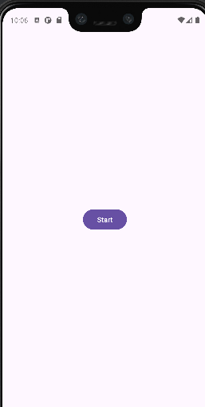 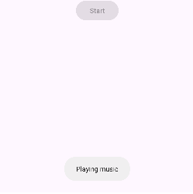

**Practical 10B**

**Aim :** Programming Telephone API

**activity_main.xml**

<?xml version="1.0" encoding="utf-8"?>  
<RelativeLayout  
 xmlns:android="http://schemas.android.com/apk/res/android"  
 xmlns:tools="http://schemas.android.com/tools"  
 android:layout_width="match_parent"  
 android:layout_height="match_parent"  
 tools:context=".MainActivity">  
 <EditText  
 android:id="@+id/editText"  
 android:layout_width="wrap_content"  
 android:layout_height="wrap_content"  
 android:layout_centerHorizontal="true"  
 android:layout_marginTop="50dp"  
 android:hint="Enter Phone Number"  
 android:inputType="phone"/>  
 <Button  
 android:id="@+id/button"  
 android:layout_width="wrap_content"  
 android:layout_height="wrap_content"  
 android:layout_centerHorizontal="true"  
 android:layout_below="@id/editText"  
 android:layout_marginTop="20dp"  
 android:text="Make Call"/>  
</RelativeLayout>

**AndroidManifest.xml**

<!-- Corrected permission declaration -->  
<uses-permission android:name="android.permission.CALL_PHONE" />  
<!-- Declare telephony as an optional feature -->  
<uses-feature android:name="android.hardware.telephony" android:required="false" />

**MainActivity.java**

package com.example.practical10b;  
import android.Manifest;  
import android.content.Intent;  
import android.content.pm.PackageManager;  
import android.net.Uri;  
import android.os.Bundle;  
import android.view.View;  
import android.widget.Button;  
import android.widget.EditText;  
import android.widget.Toast;  
import androidx.appcompat.app.AppCompatActivity;  
import androidx.core.app.ActivityCompat;  
import androidx.core.content.ContextCompat;  
public class MainActivity extends AppCompatActivity {  
 EditText editText;  
 Button button;  
 private static final int *REQUEST_CALL_PERMISSION* = 1;  
 @Override  
 protected void onCreate(Bundle savedInstanceState) {  
 super.onCreate(savedInstanceState);  
 setContentView(R.layout.*activity_main*);  
 editText = findViewById(R.id.*editText*);  
 button = findViewById(R.id.*button*);  
 button.setOnClickListener(new View.OnClickListener() {  
 @Override  
 public void onClick(View v) {  
 makePhoneCall();  
 }  
 });  
 }  
 private void makePhoneCall() {  
 String phoneNumber = editText.getText().toString();  
 if (phoneNumber.isEmpty()) {  
 Toast.*makeText*(this, "Enter a phone number", Toast.*LENGTH_SHORT*).show();  
 return;  
 }  
 Intent phoneIntent = new Intent(Intent.*ACTION_CALL*);  
 phoneIntent.setData(Uri.*parse*("tel:" + phoneNumber));  
 if (ContextCompat.*checkSelfPermission*(MainActivity.this, Manifest.permission.*CALL_PHONE*)  
 != PackageManager.*PERMISSION_GRANTED*) {  
 ActivityCompat.*requestPermissions*(MainActivity.this,  
 new String[]{Manifest.permission.*CALL_PHONE*}, *REQUEST_CALL_PERMISSION*);  
 } else {  
 startActivity(phoneIntent);  
 }  
 }  
 @Override  
 public void onRequestPermissionsResult(int requestCode, String[] permissions, int[] grantResults) {  
 super.onRequestPermissionsResult(requestCode, permissions, grantResults);  
 if (requestCode == *REQUEST_CALL_PERMISSION*) {  
 if (grantResults.length > 0 && grantResults[0] == PackageManager.*PERMISSION_GRANTED*) {  
 makePhoneCall();  
 } else {  
 Toast.*makeText*(this, "Permission Denied", Toast.*LENGTH_SHORT*).show();  
 }}}}

**Output:**

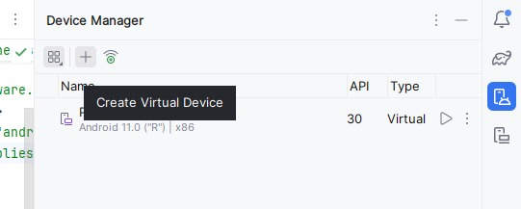 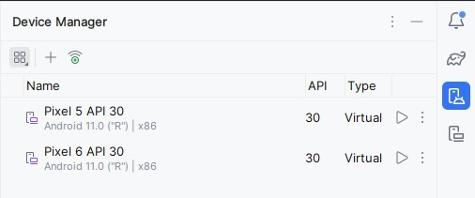

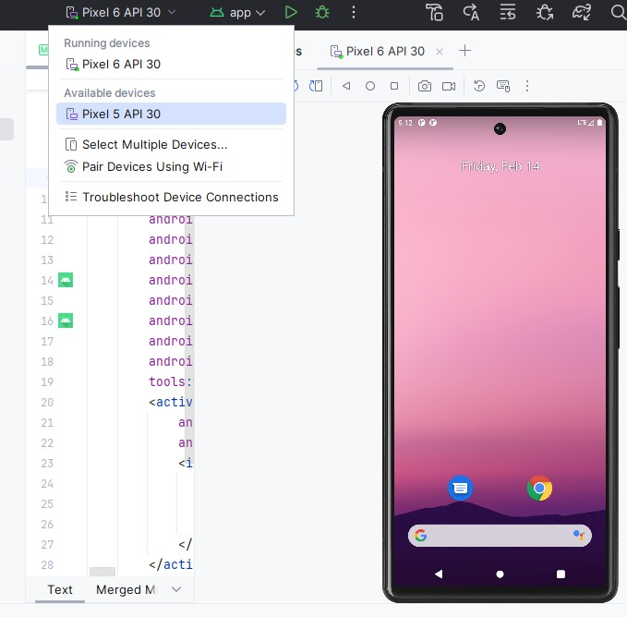

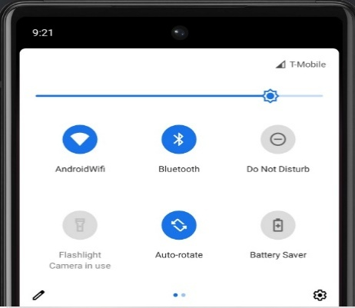 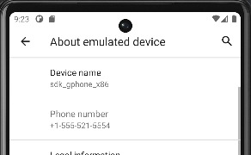

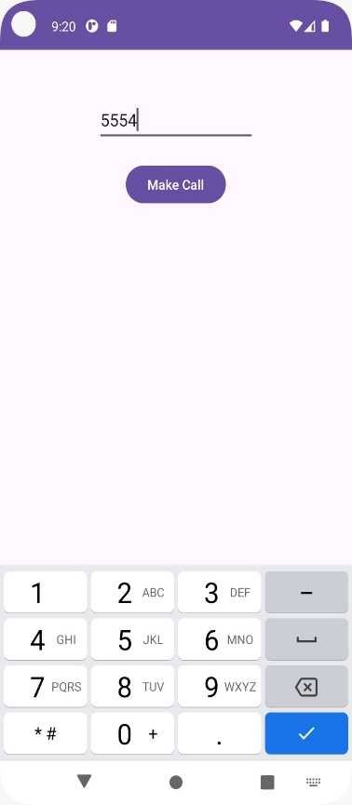 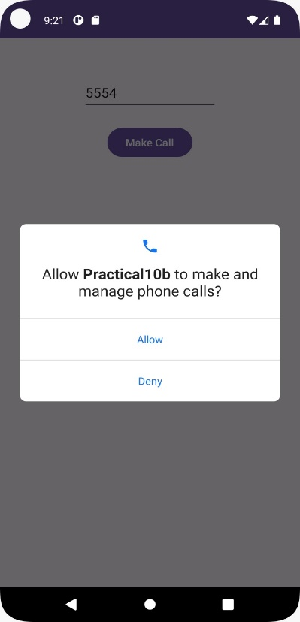

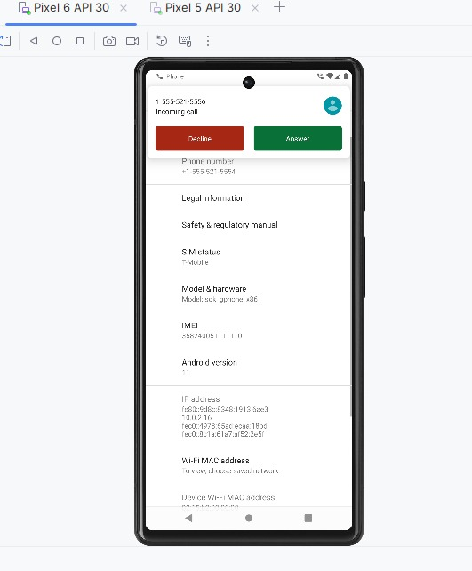 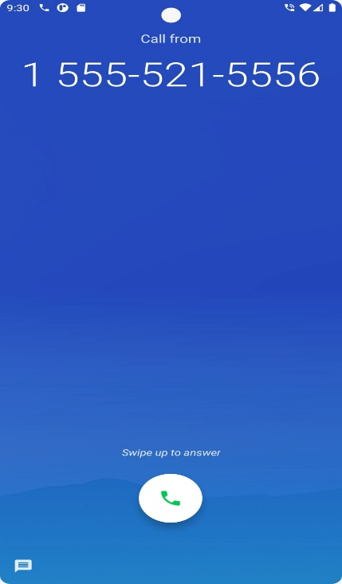

**Practical 10C**

**Aim :** Programming Security and permissions

**activity_main.xml**

<?xml version="1.0" encoding="utf-8"?>  
<RelativeLayout xmlns:android="http://schemas.android.com/apk/res/android"  
 xmlns:app="http://schemas.android.com/apk/res-auto"  
 xmlns:tools="http://schemas.android.com/tools"  
 android:id="@+id/main"  
 android:layout_width="match_parent"  
 android:layout_height="match_parent"  
 tools:context=".MainActivity">  
 <!-- A TextView example -->  
 <TextView  
 android:id="@+id/textView"  
 android:layout_width="wrap_content"  
 android:layout_height="wrap_content"  
 android:text="Hello, World!"  
 android:textSize="48sp"  
 android:layout_centerInParent="true" />  
 <!-- A Button example -->  
 <Button  
 android:id="@+id/button"  
 android:layout_width="wrap_content"  
 android:layout_height="wrap_content"  
 android:text="Click Me"  
 android:layout_below="@id/textView"  
 android:layout_centerHorizontal="true"  
 android:layout_marginTop="30dp" />  
</RelativeLayout>

**AndroidManifest.xml**

<?xml version="1.0" encoding="utf-8"?>  
<manifest xmlns:android="http://schemas.android.com/apk/res/android"  
 xmlns:tools="http://schemas.android.com/tools">  
 <uses-permission android:name="android.permission.CAMERA"  
 tools:ignore="PermissionImpliesUnsupportedChromeOsHardware" />  
 <uses-permission android:name="android.permission.ACCESS_FINE_LOCATION"/>  
 <uses-permission android:name="android.permission.ACCESS_COARSE_LOCATION"/>

**MainActivity.java**

package com.example.practical10c;  
import android.content.pm.PackageManager;  
import android.os.Bundle;  
import android.view.View;  
import android.widget.Button;  
import android.widget.Toast;  
import androidx.annotation.NonNull;  
import androidx.appcompat.app.AppCompatActivity;  
import androidx.core.app.ActivityCompat;  
import androidx.core.content.ContextCompat;  
public class MainActivity extends AppCompatActivity {  
 private static final int *CAMERA_PERMISSION_CODE* = 100;  
 @Override  
 protected void onCreate(Bundle savedInstanceState) {  
 super.onCreate(savedInstanceState);  
 setContentView(R.layout.*activity_main*);  
 // Check if the app already has camera permission  
 if (ContextCompat.*checkSelfPermission*(this, android.Manifest.permission.*CAMERA*)  
 == PackageManager.*PERMISSION_GRANTED*) {  
 // Permission is already granted  
 Toast.*makeText*(this, "Permission is already granted", Toast.*LENGTH_SHORT*).show();  
 } else {  
 // Request camera permission  
 Toast.*makeText*(this, "Requesting Permission", Toast.*LENGTH_SHORT*).show();  
 requestCameraPermission();  
 }  
 }  
 // Method to request camera permission  
 public void requestCameraPermission() {  
 ActivityCompat.*requestPermissions*(this,  
 new String[]{android.Manifest.permission.*CAMERA*},  
 *CAMERA_PERMISSION_CODE*);  
 }  
 // Handle the result of the permission request  
 @Override  
 public void onRequestPermissionsResult(int requestCode, @NonNull String[] permissions, @NonNull int[] grantResults) {  
 super.onRequestPermissionsResult(requestCode, permissions, grantResults);  
 if (requestCode == *CAMERA_PERMISSION_CODE*) {  
 if (grantResults.length > 0 && grantResults[0] == PackageManager.*PERMISSION_GRANTED*) {  
 // Permission was granted  
 Toast.*makeText*(this, "Camera Permission Granted", Toast.*LENGTH_SHORT*).show();  
 } else {  
 // Permission was denied  
 Toast.*makeText*(this, "Camera Permission Denied", Toast.*LENGTH_SHORT*).show();  
 }  
 }  
 }  
}

**Output:**

